**DATABASE MANAGEMENT SYSTEM**

**(01CT0407)**

**Department of Information Communication and Technology**

**4rd Semester**

**Lab Manual**

**(Dec-Apr 23-24)**

**Index**

|  |  |
| --- | --- |
| **Lab** | **Programs** |
| 1 | Introduction to RDBMS and APEX Login |
| 2 | DDL Commands and Table Creation |
| 3 | DML Commands and Queries |
| 4 | DML Commands and Related Queries |
| 5 | Constraint-Based DML Commands |
| 6 | Functions and Queries |
| 7 | Implement operator, null and special operator-based queries |
| 8 | Implement Constraint-based and Group by related queries |
| 9 | Range Function and Operator based Queries |
| 10 | Join based Queries having Functions |
| 11 | Understand and implement Conditions and looping in PL/SQL |
| 12 | Implement a PL/SQL Block |
| 13 | Implement a Procedure and Function for given Statement |
| 14 | Understand and Implement Triggers |

**Practical 1**

**Aim: Introduction to RDBMS and APEX Login.**

**APEX login:**

Step 1:https://apex.oracle.com/pls/apex/

Step 2: Click on Request a workspace.

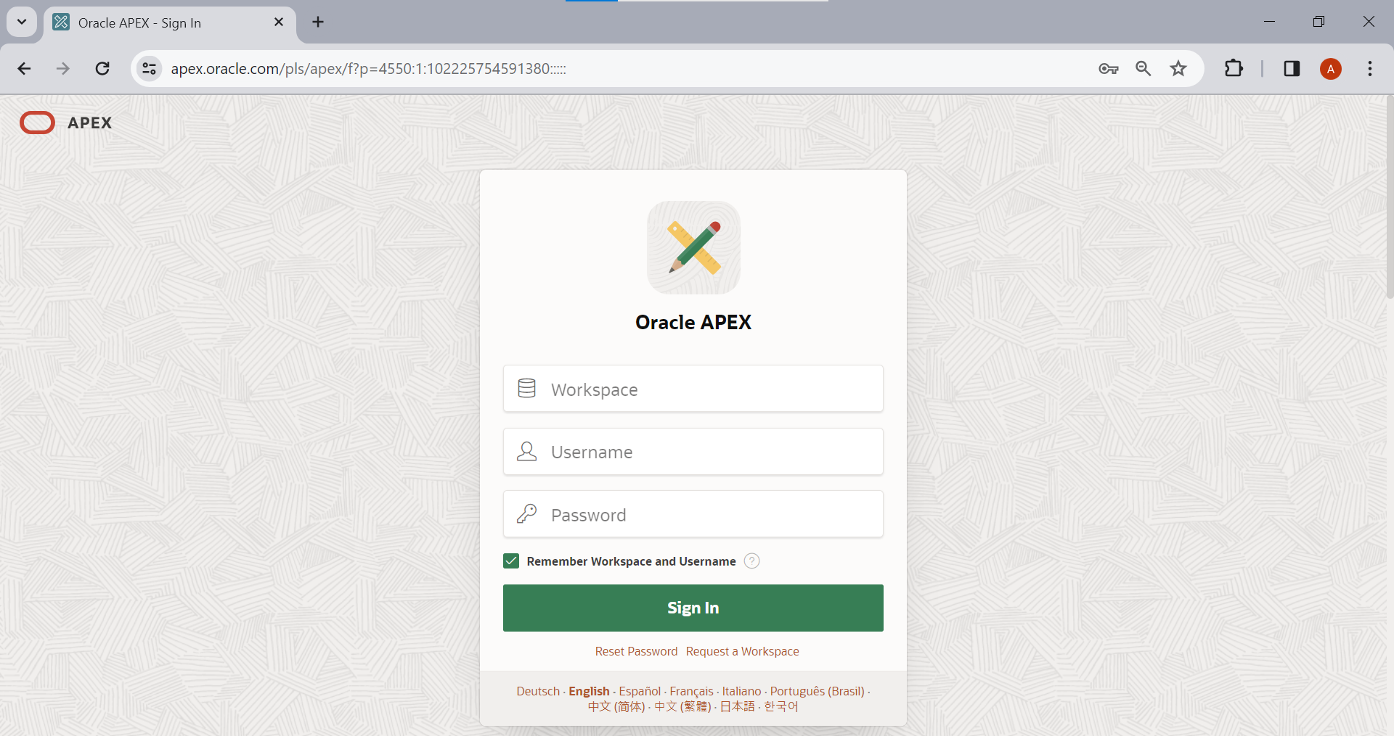

Step 3:Fill all the required details carefully like: First Name: Your name(ex. Harikesh)

Last Name: Your last name (ex. Chauhan)

Email: Use your institute email address only.

Workspace:name_surname And click on next.

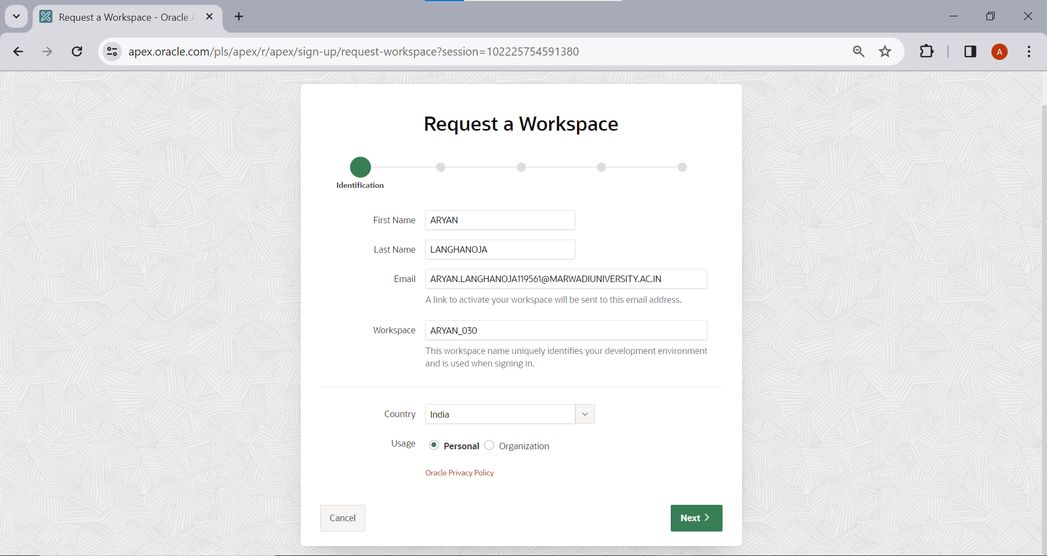

Step 4: Fill survey detail same as below and click on next.

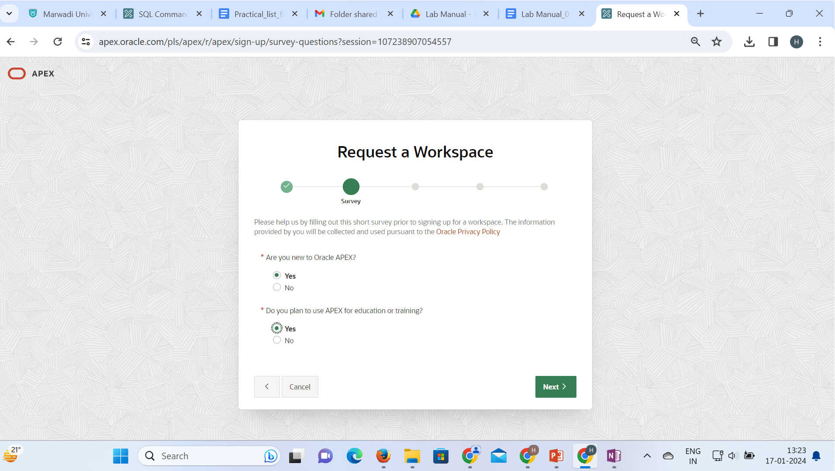

Step 5: Write appropriate text in textarea and Click on next,

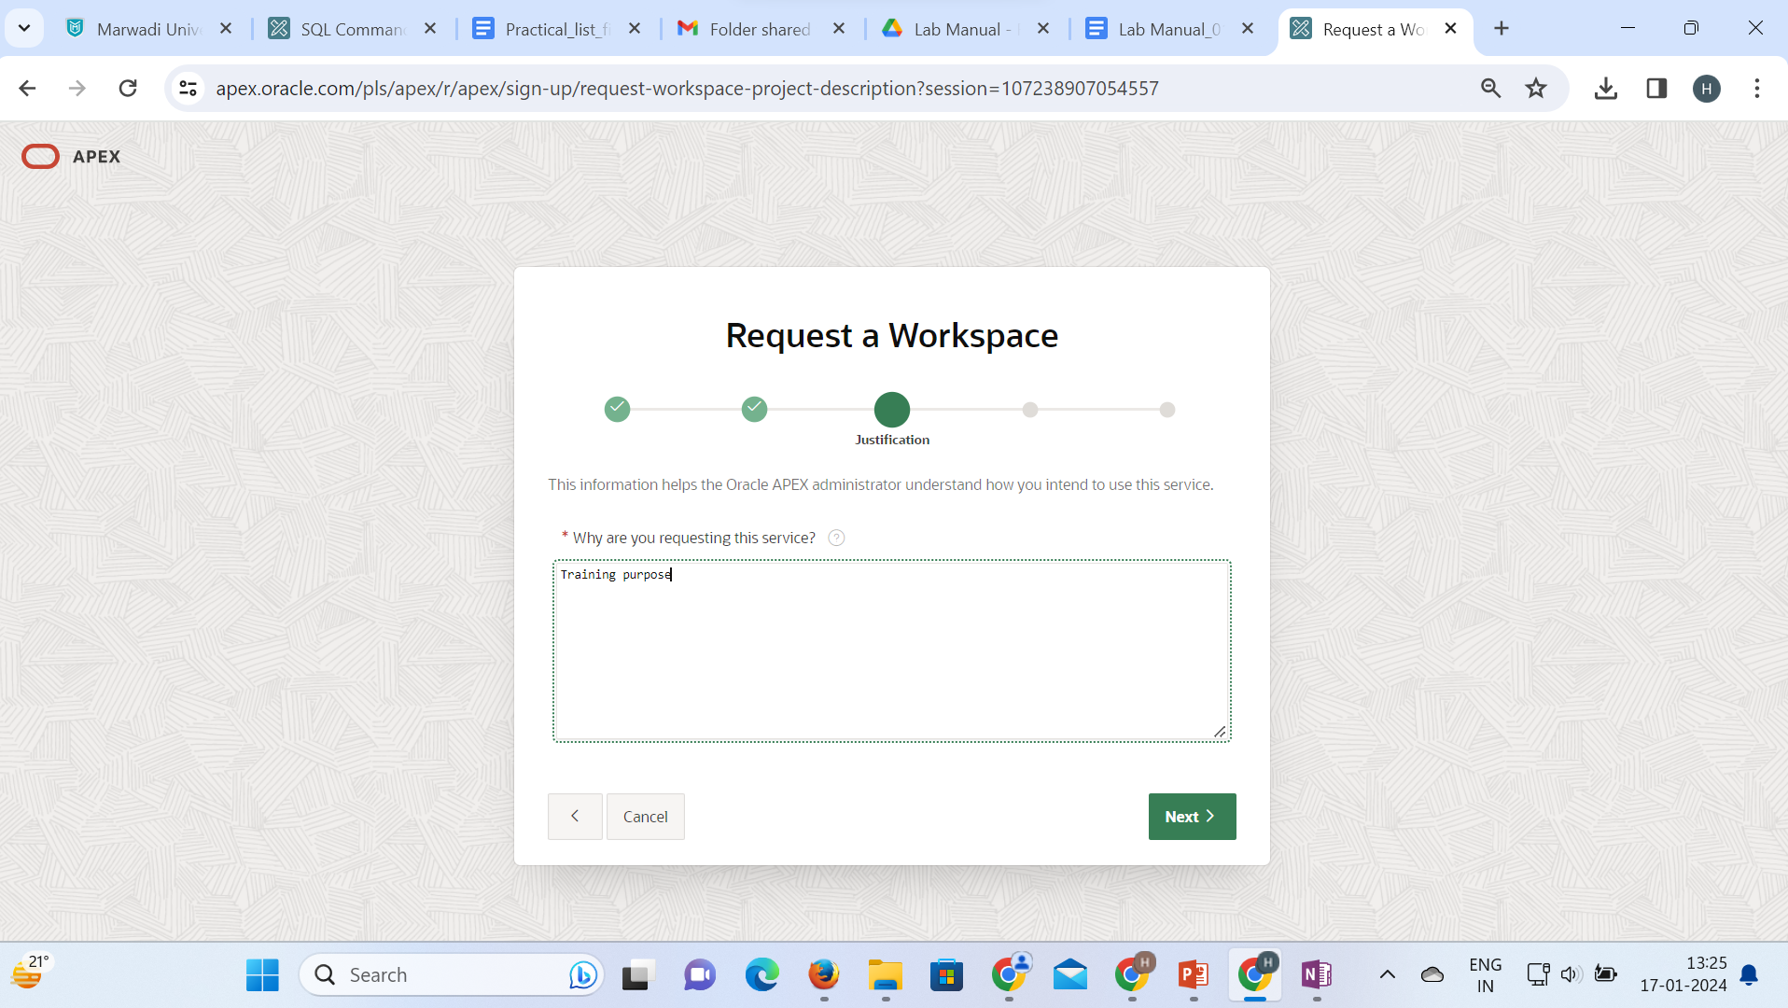

Step 6:Click on check box to agree terms and conditions and Click on next.

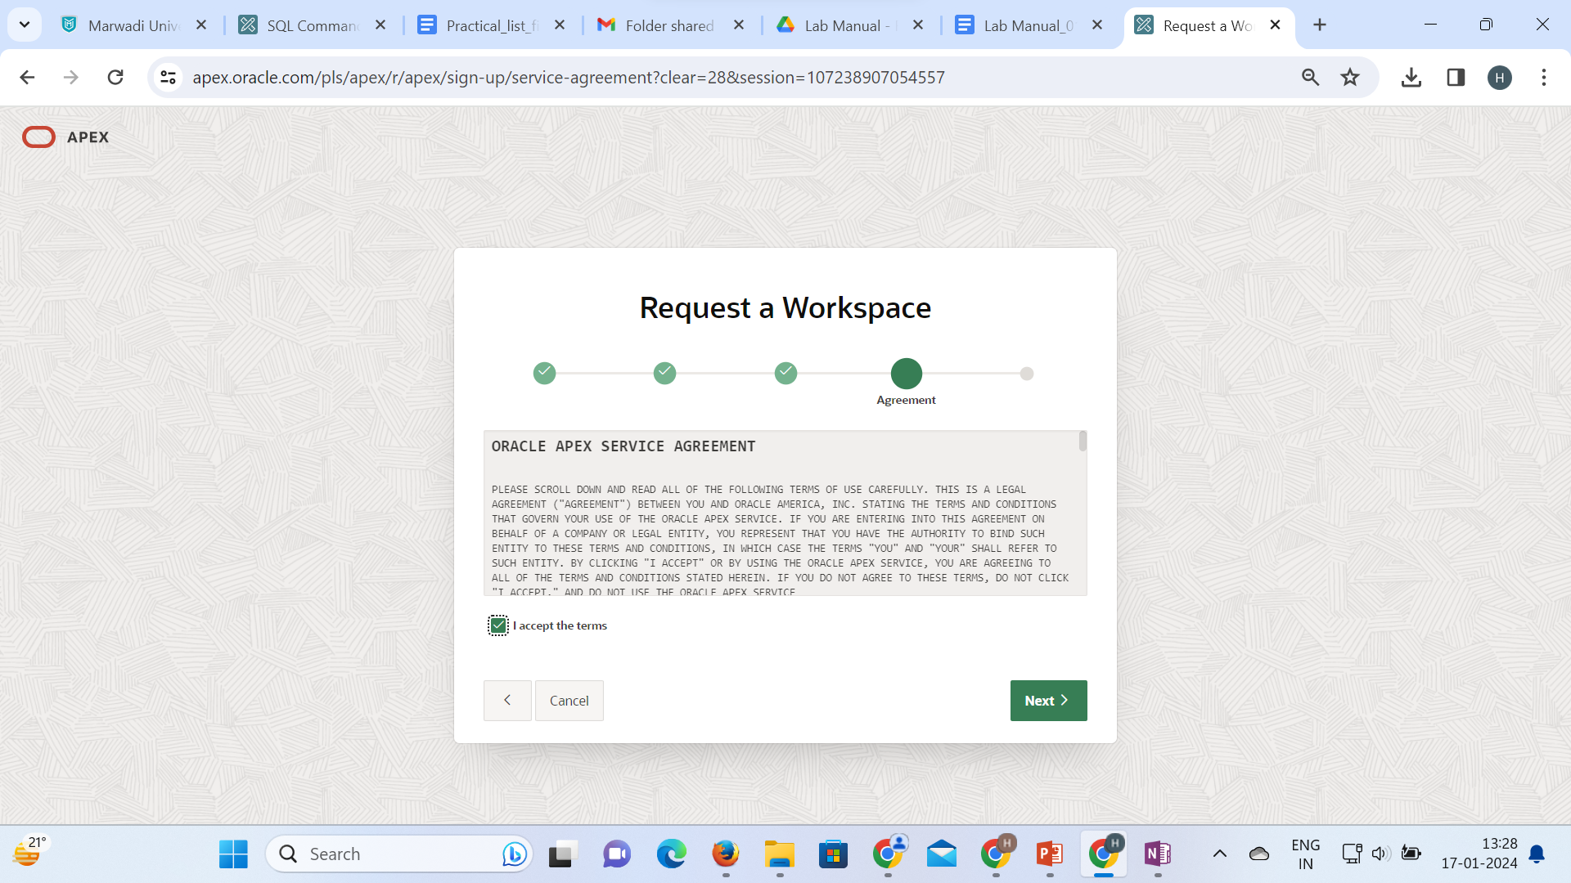

Step 7:Click on submit request button and Click on next

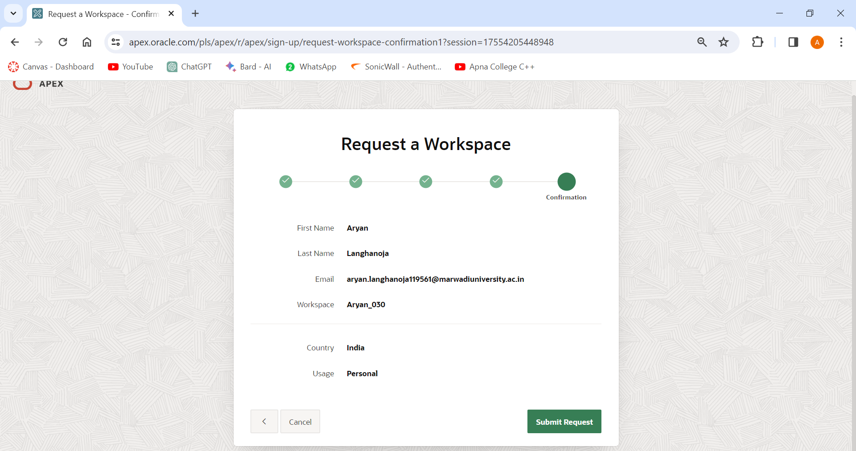

Step 8: After that you will receive an email on your institute email id.

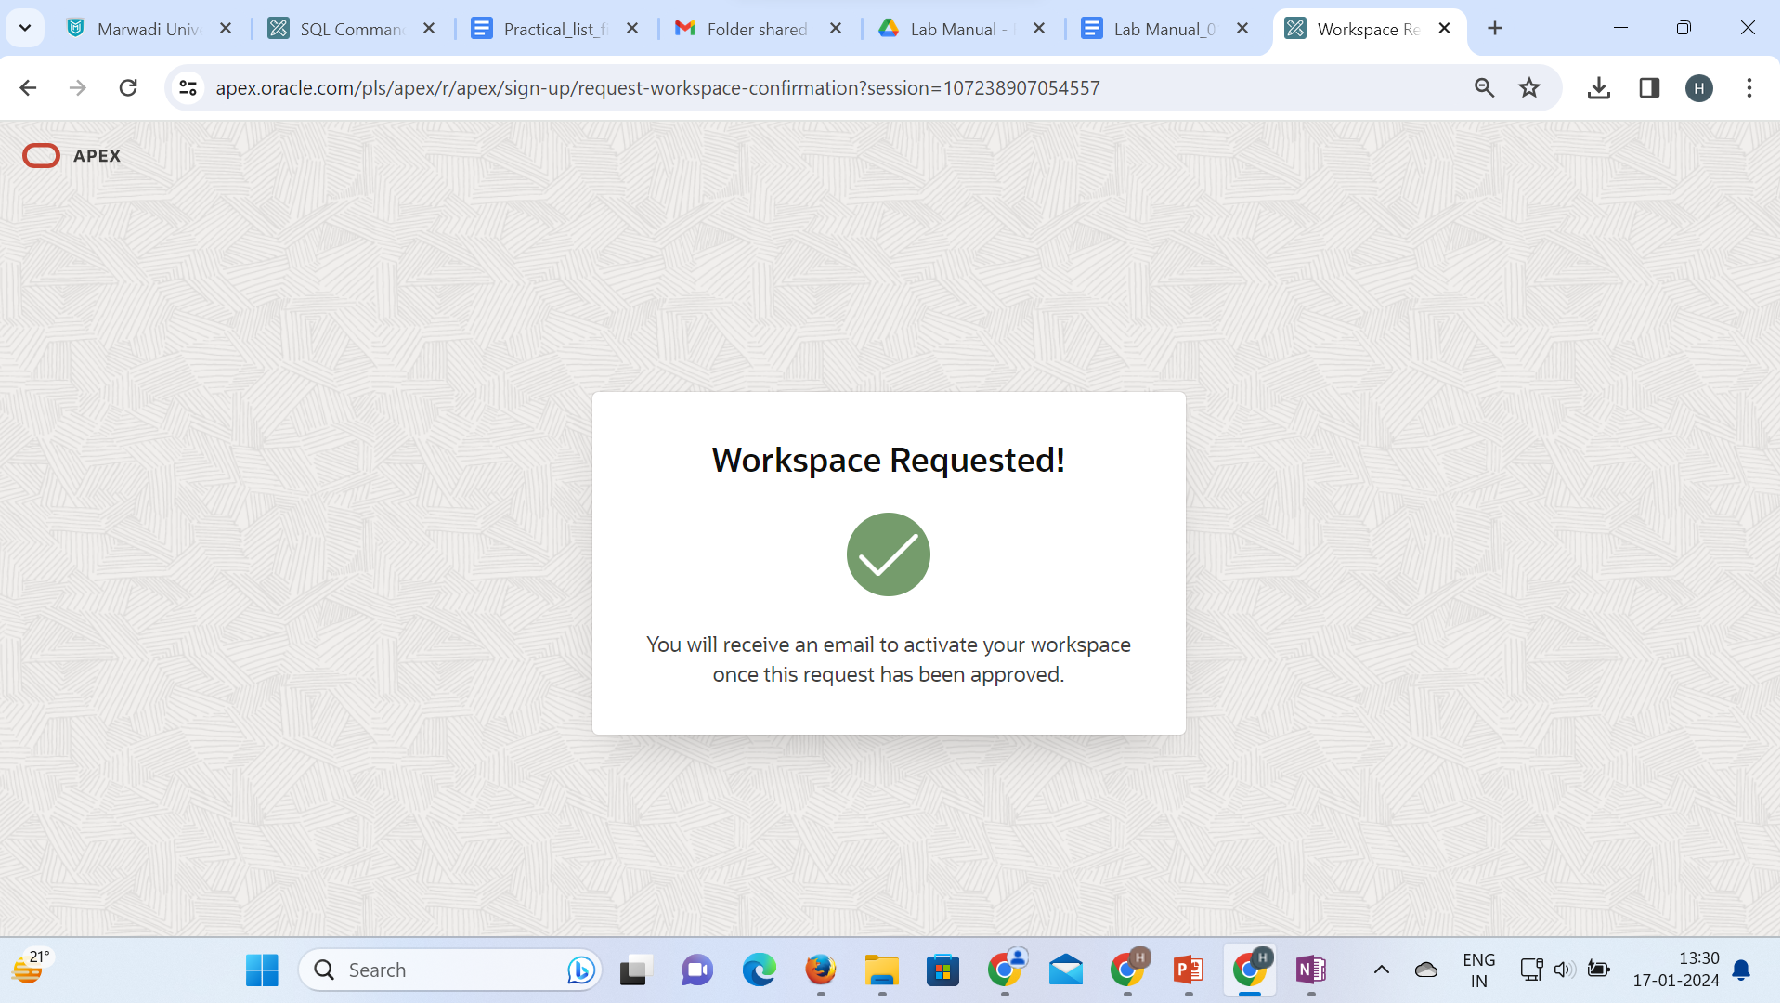

Step 9: Click on create workspace.

Step 10: Click on Continue to sign in screen.

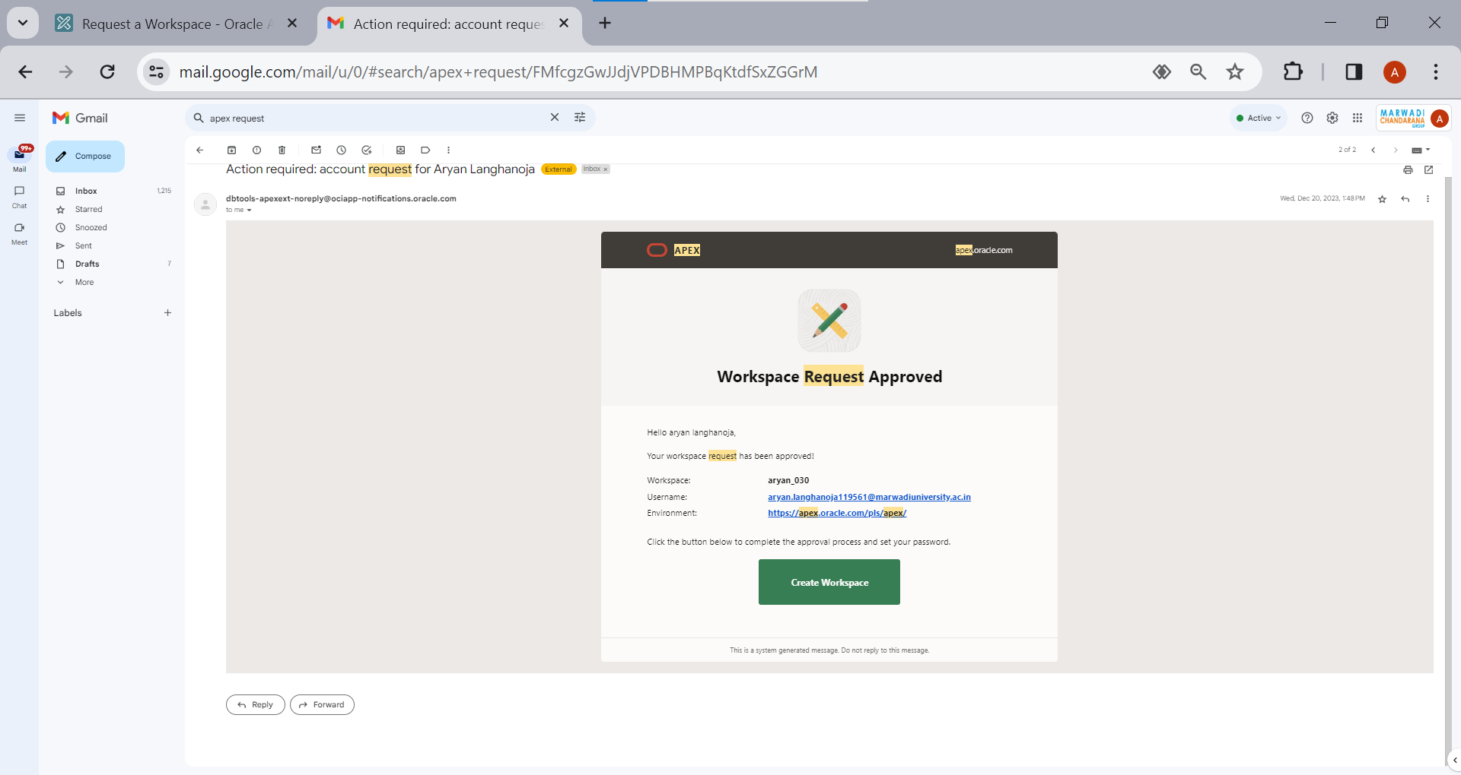

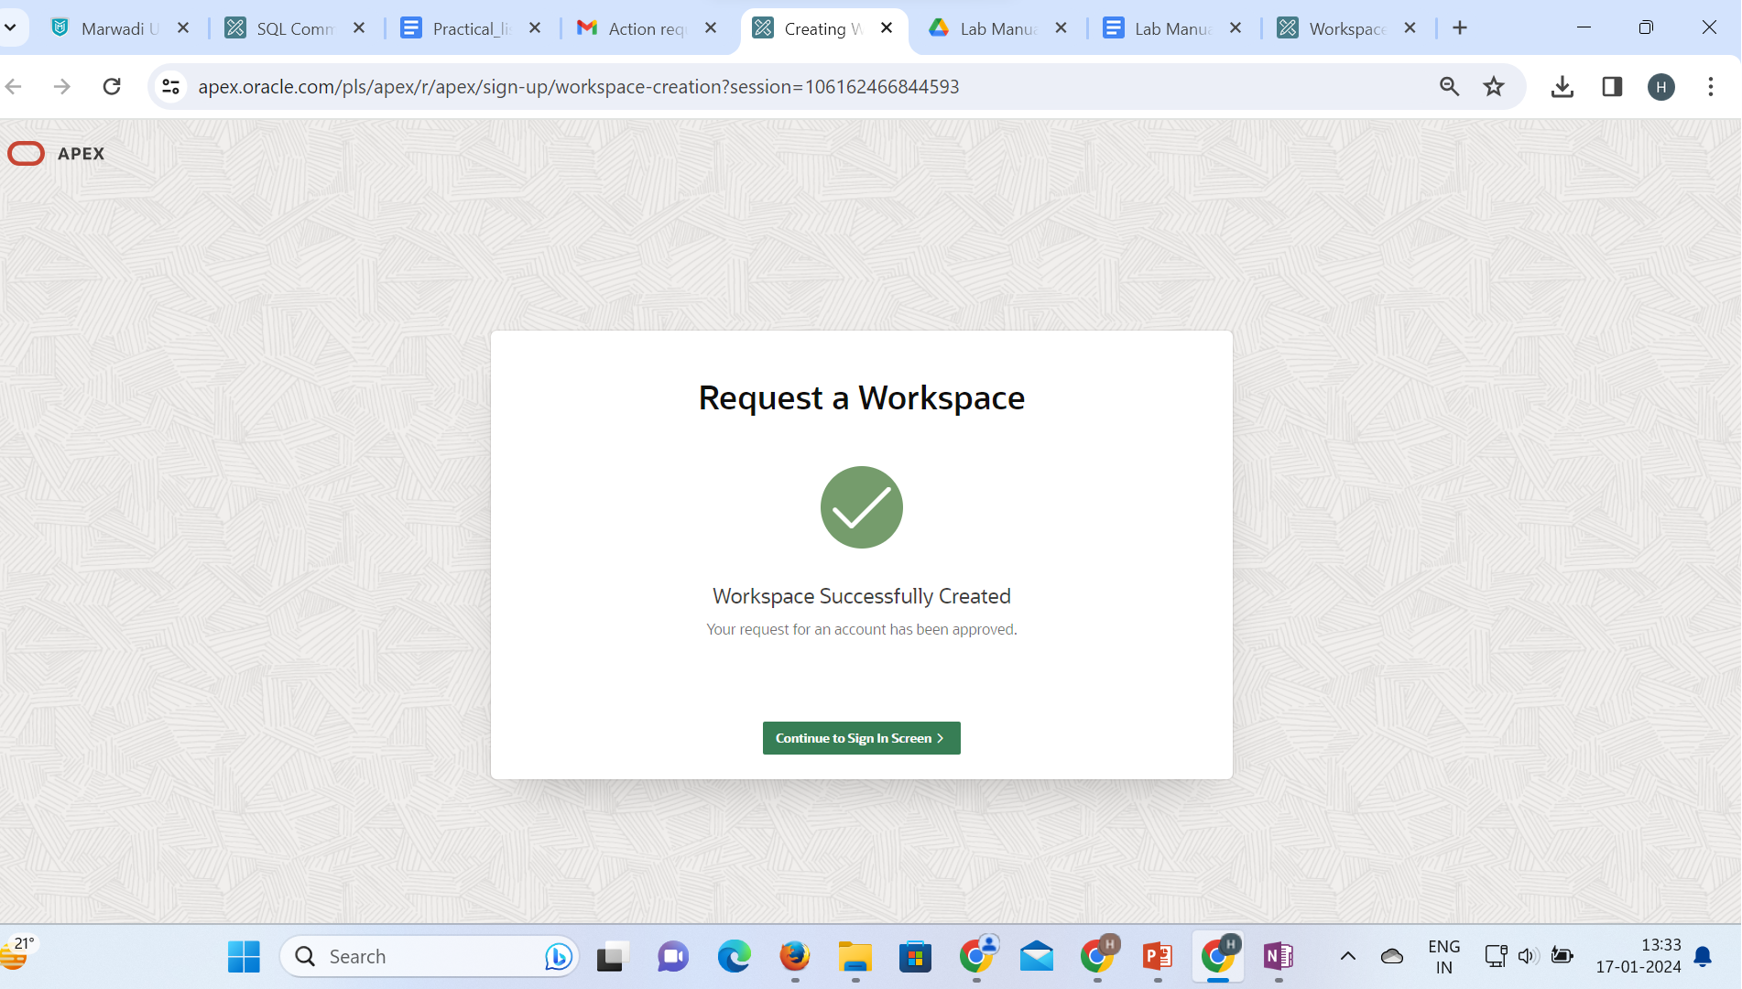

Step 11: Set your new password and confirm password and click on change password.

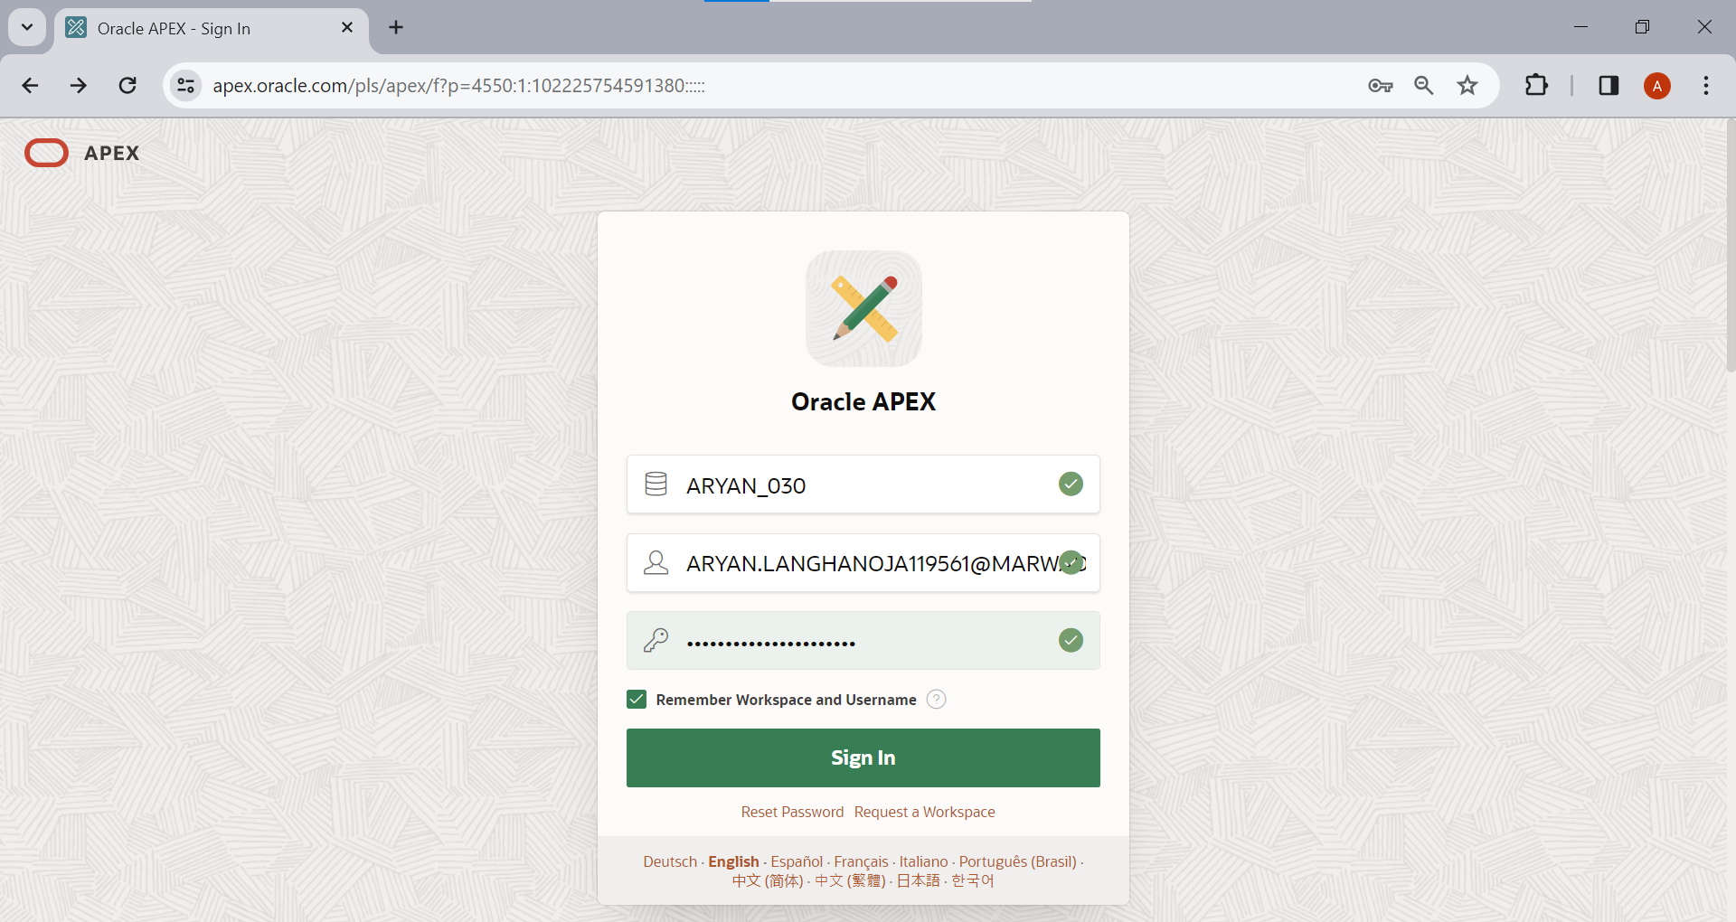

Step 12: Click on SQL workshop.

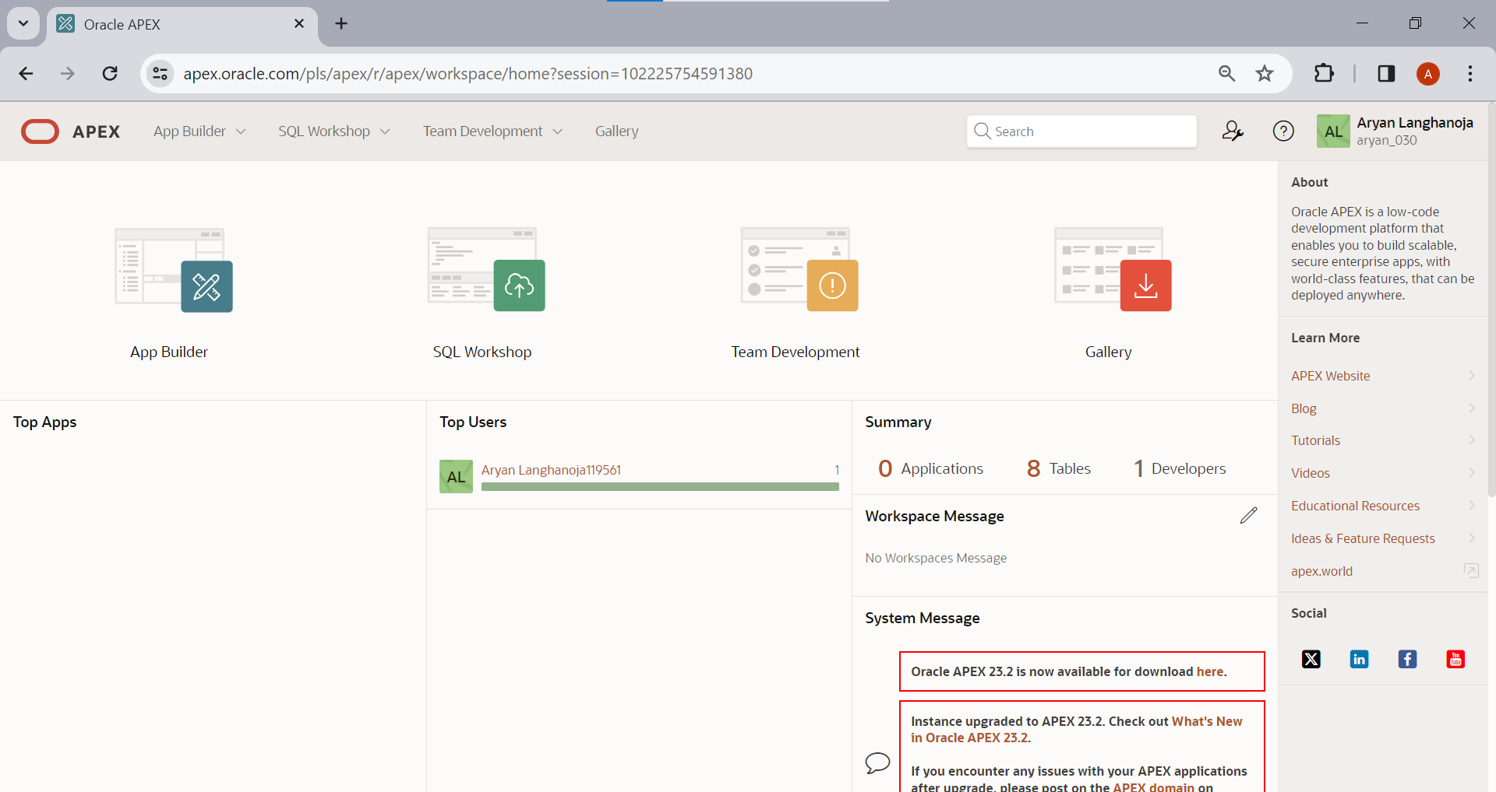

Step 13: Click on SQL Commands.

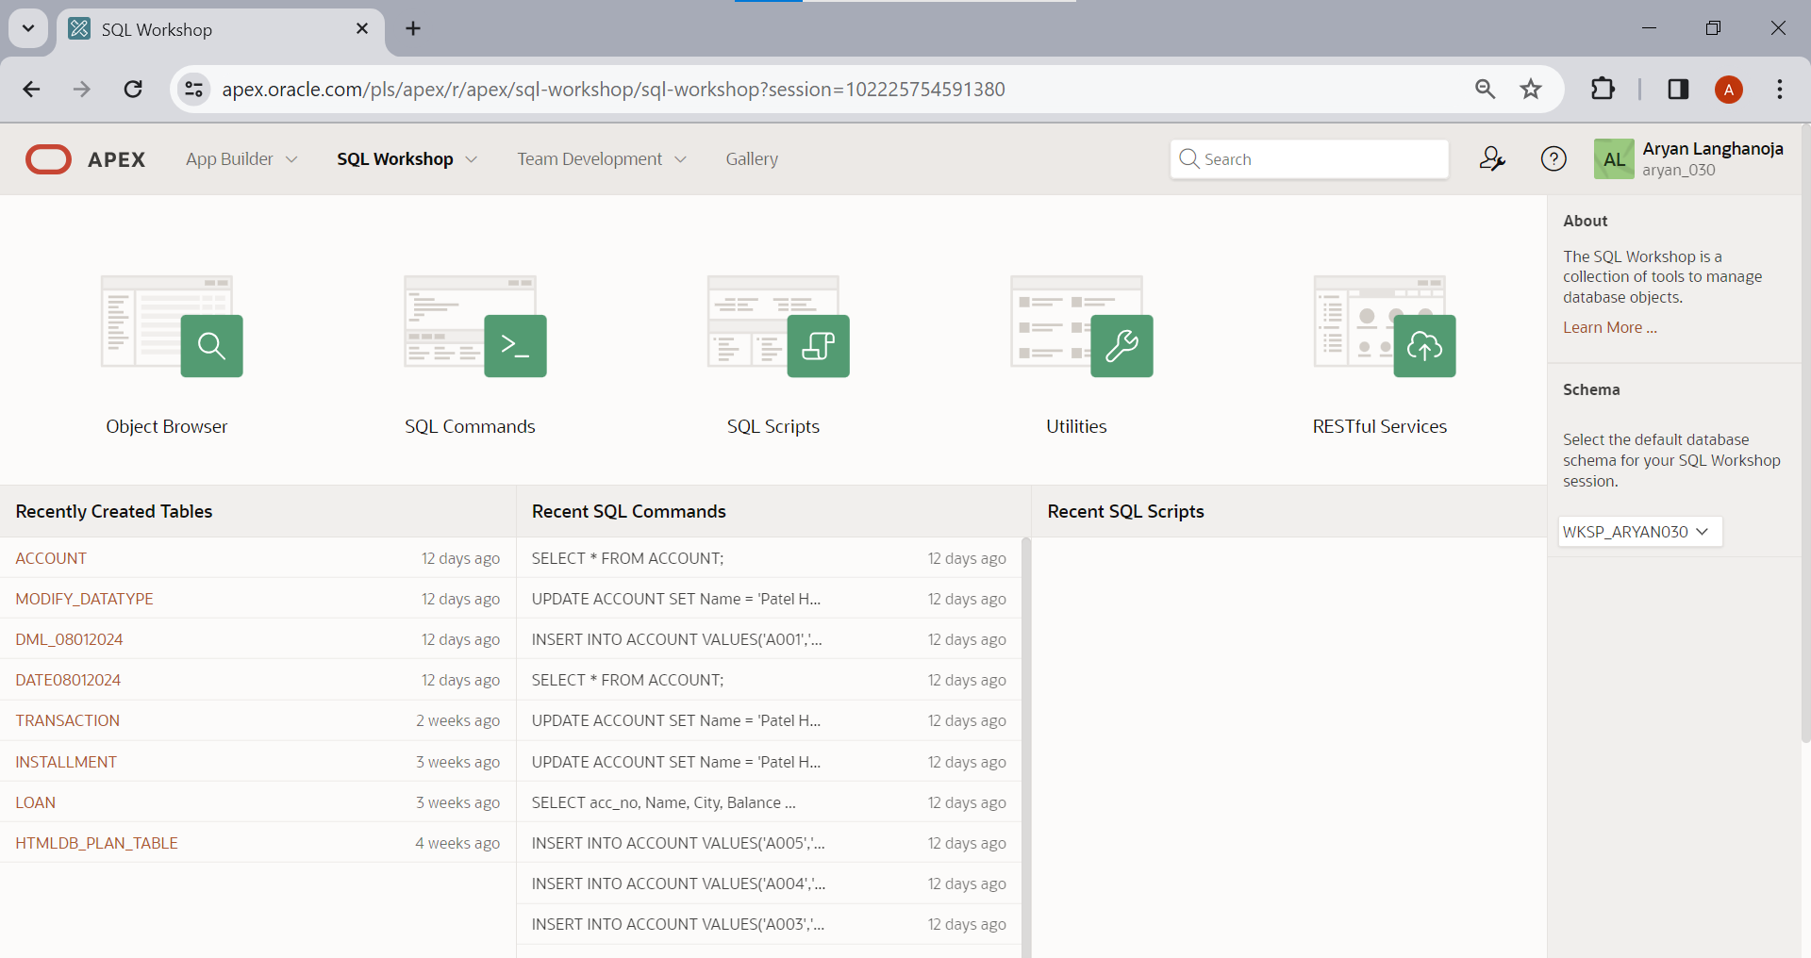

Step 14: Now you can perform your queries.

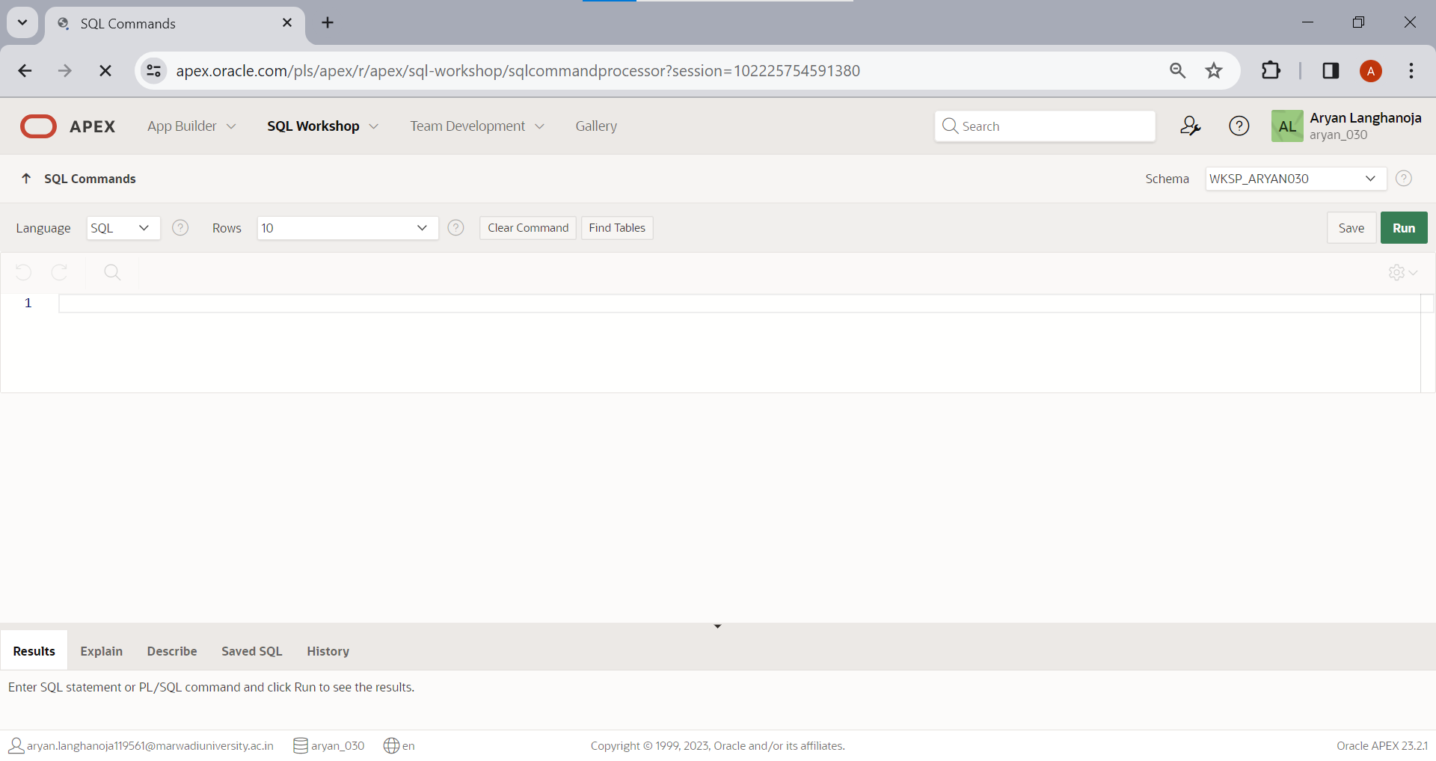

**Practical 2**

**Aim: DDL Commands and Table Creation**.

**Create a table ACCOUNT**

|  |  |  |
| --- | --- | --- |
| **Column name** | **Data Type** | **Size** |
| acc_no | varchar2 | 5 |
| Name | varchar2 | 30 |
| City | varchar2 | 20 |
| Balance | Number | 10,2 |
| loan_taken | varchar2 | 5 |

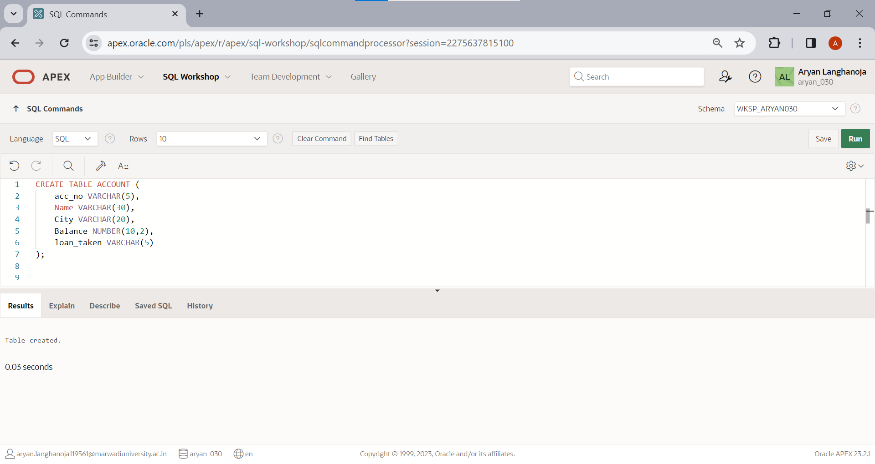

**Insert the following records.**

|  |  |  |  |  |
| --- | --- | --- | --- | --- |
| **acc_no** | **Name** | **City** | **Balance** | **loan_taken** |
| A001 | Patel Jigar | Mehsana | 50000 | YES |
| A002 | Patel Ramesh | Mehsana | 50000 | YES |
| A003 | Dave Hardik | Ahmedabad | 75000 | NO |
| A004 | Soni Hetal | Ahmedabad | 100000 | NO |
| A005 | Sony Atul | Vadodara | 100000 | YES |

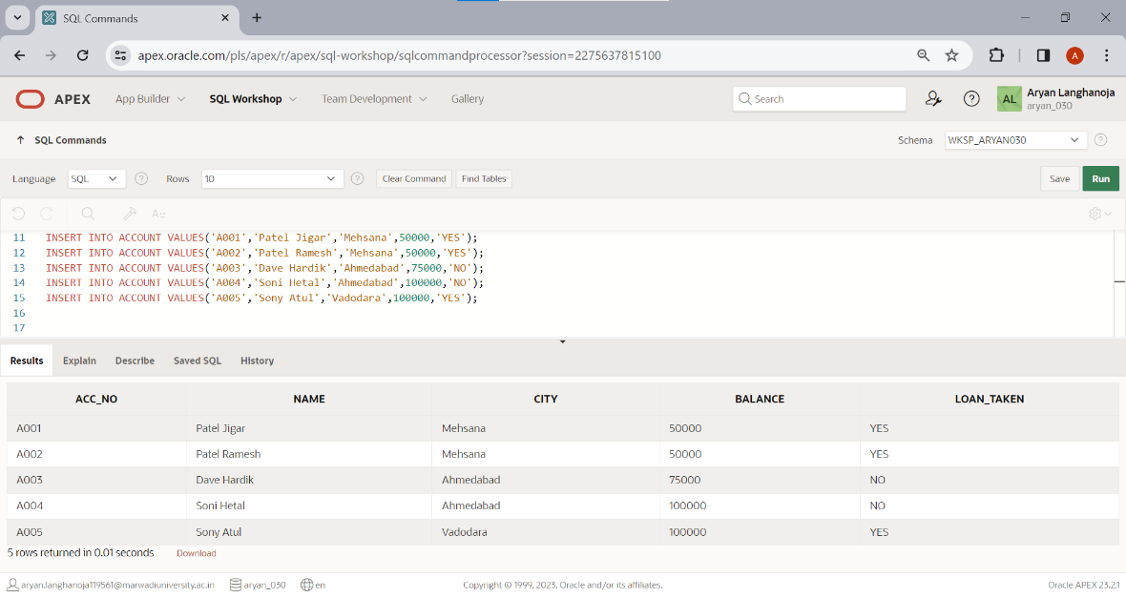

**Create a Table LOAN**

|  |  |  |
| --- | --- | --- |
| **Column Name** | **Data Type** | **Size** |
| loan_no | varchar2 | 5 |
| acc_no | varchar2 | 5 |
| loan_amt | number | 10,2 |
| interest_rate | number | 5,2 |
| loan_date | date |  |
| remaining_loan | number | 10,2 |

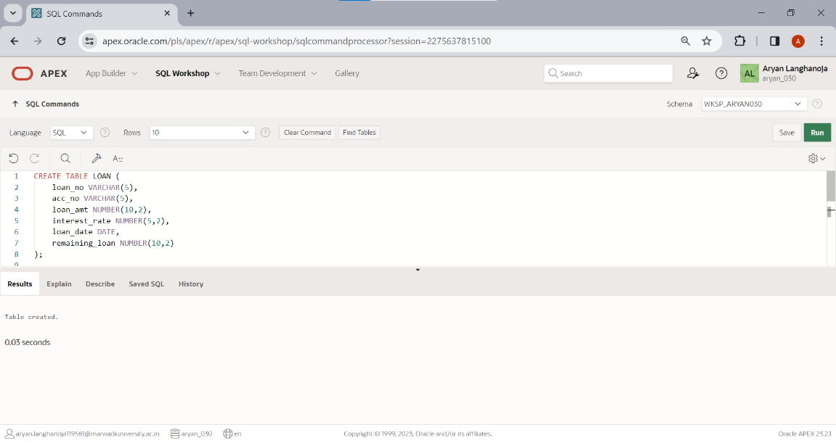

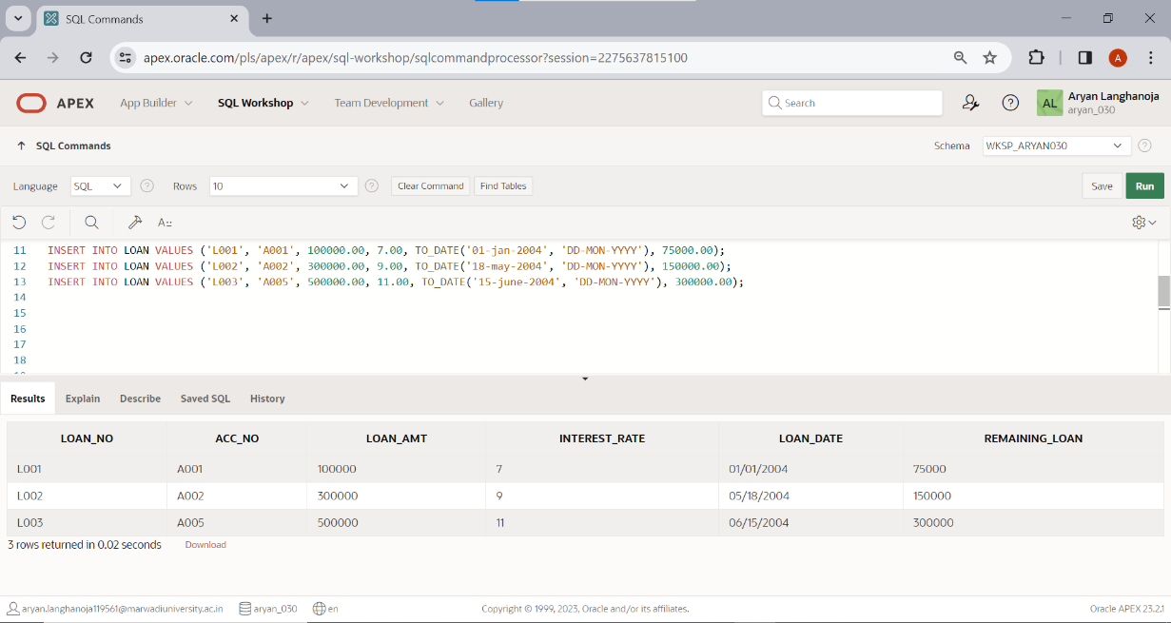**Insert the following Records.**

|  |  |  |  |  |  |
| --- | --- | --- | --- | --- | --- |
| **Loan_no** | **Acc_no** | **Loan_amt** | **Interest_rate** | **Loan_date** | **Remaining_loan** |
| L001 | A001 | 100000 | 7 | 1-jan-04 | 75000 |
| L002 | A002 | 300000 | 9 | 18-may-04 | 150000 |
| L003 | A005 | 500000 | 11 | 15-june-04 | 300000 |

**Create a table INSTALLMENT**

|  |  |  |
| --- | --- | --- |
| **Column Name** | **Data Type** | **Size** |
| loan_no | varchar2 | 5 |
| inst_no | varchar2 | 5 |
| inst_Date | Date |  |
| Amount | Number | 10,2 |

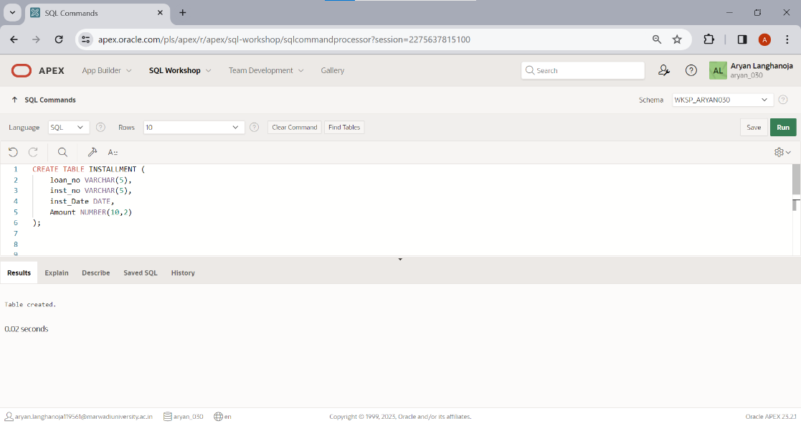

**Insert following Records**

|  |  |  |  |
| --- | --- | --- | --- |
| **Loan_no** | **Inst_no** | **Date** | **Amount** |
| L001 | I001 | 2-Feb-04 | 15000 |
| L002 | I002 | 18-June-04 | 20000 |
| L003 | I003 | 15-July-04 | 20000 |

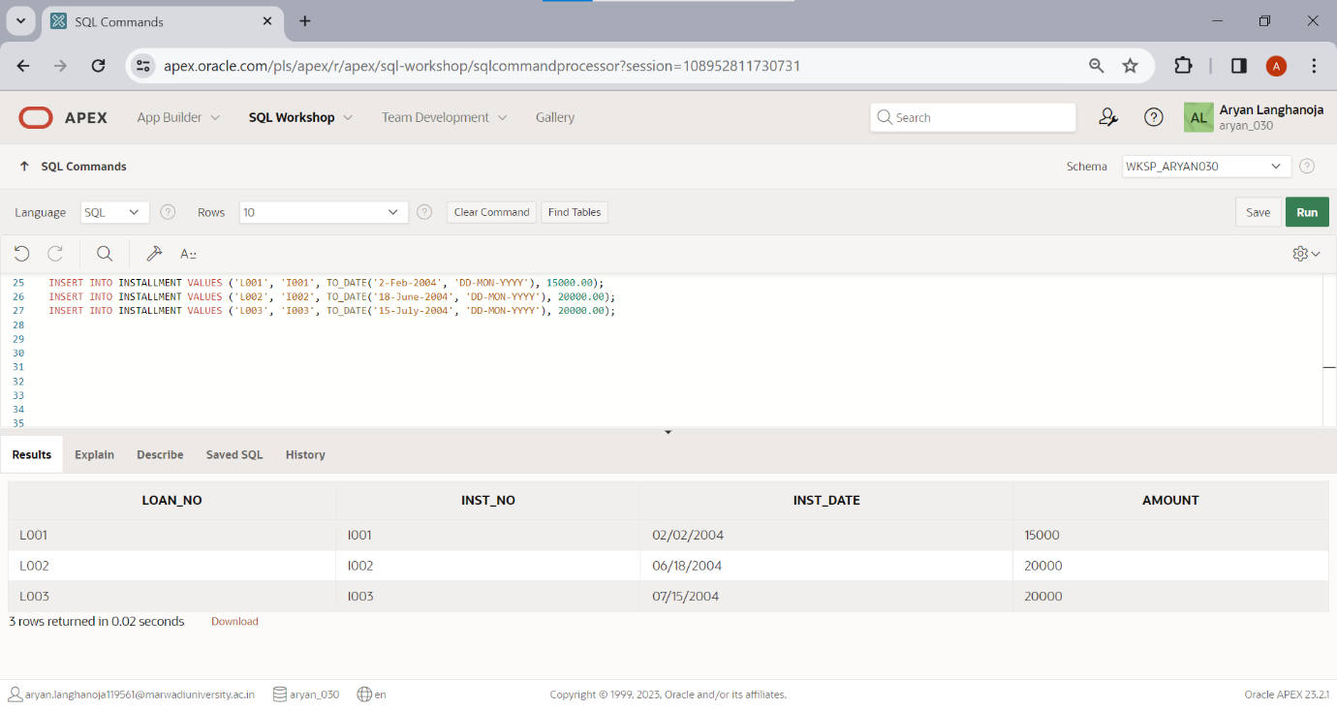

**Create a Table TRANSACTION**

|  |  |  |
| --- | --- | --- |
| **Column Name** | **Data Type** | **Size** |
| acc_no | Varchar2 | 5 |
| tr_Date | Date |  |
| Amt | Number | 10,2 |
| type_of_tr | Char | 1 |
| mode_of_pay | Varchar2 | 10 |

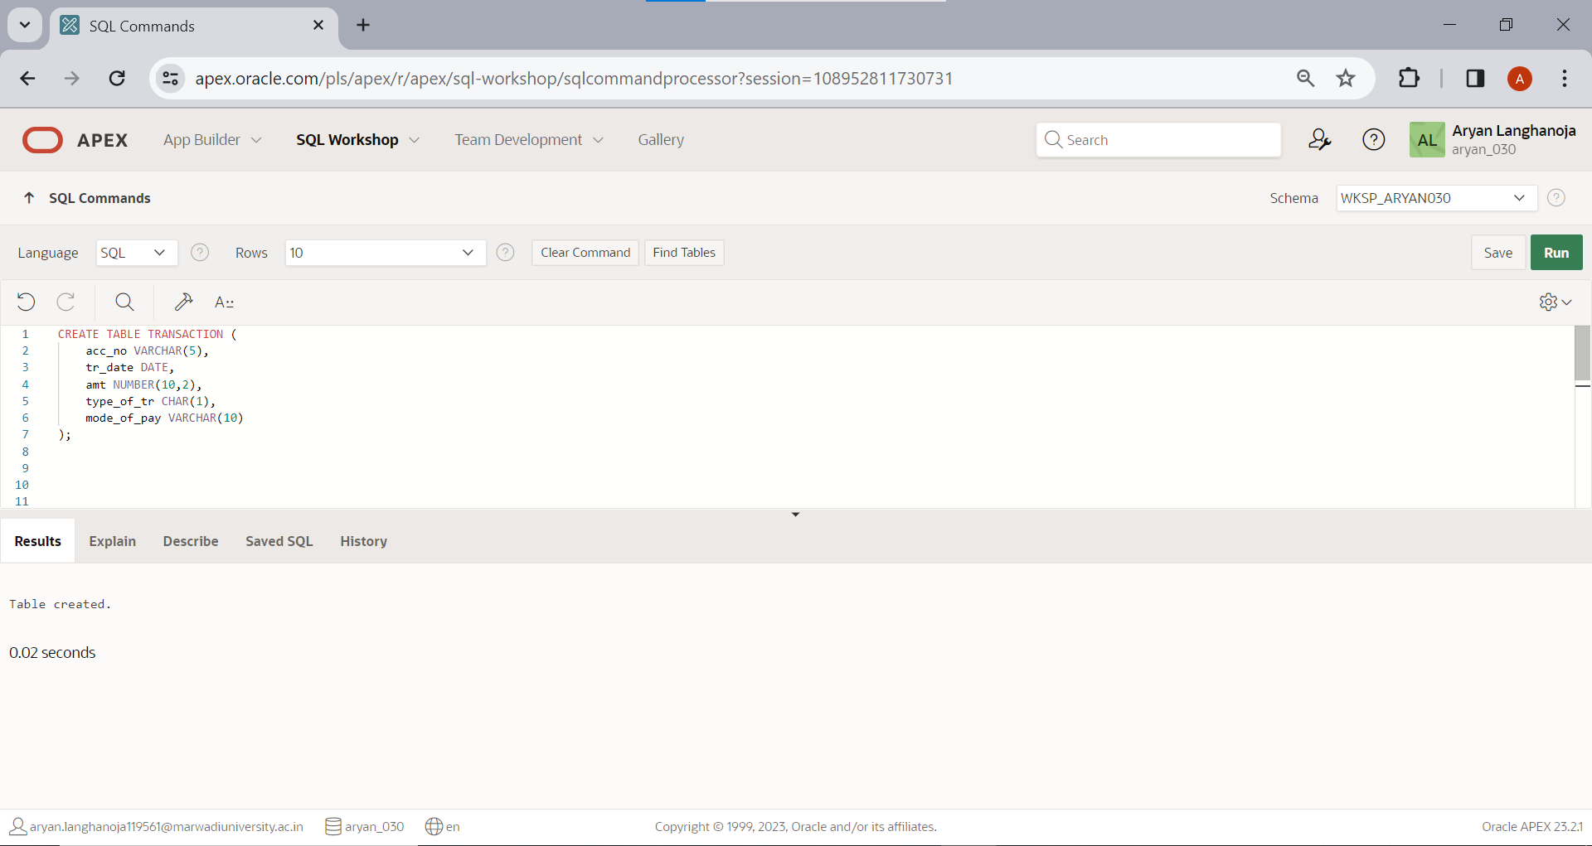

**Insert a Following Records**

|  |  |  |  |  |
| --- | --- | --- | --- | --- |
| **Acc_no** | **Date** | **Amt** | **Type_of_tr** | **Mode_of_pay** |
| A001 | 3-may-04 | 10000 | D | Cash |
| A002 | 5-july-04 | 5000 | W | Cheque |
| A003 | 12-Aug-04 | 25000 | D | Cheque |
| A004 | 15-may-04 | 30000 | D | Cheque |
| A005 | 22-oct-04 | 15000 | W | Cash |

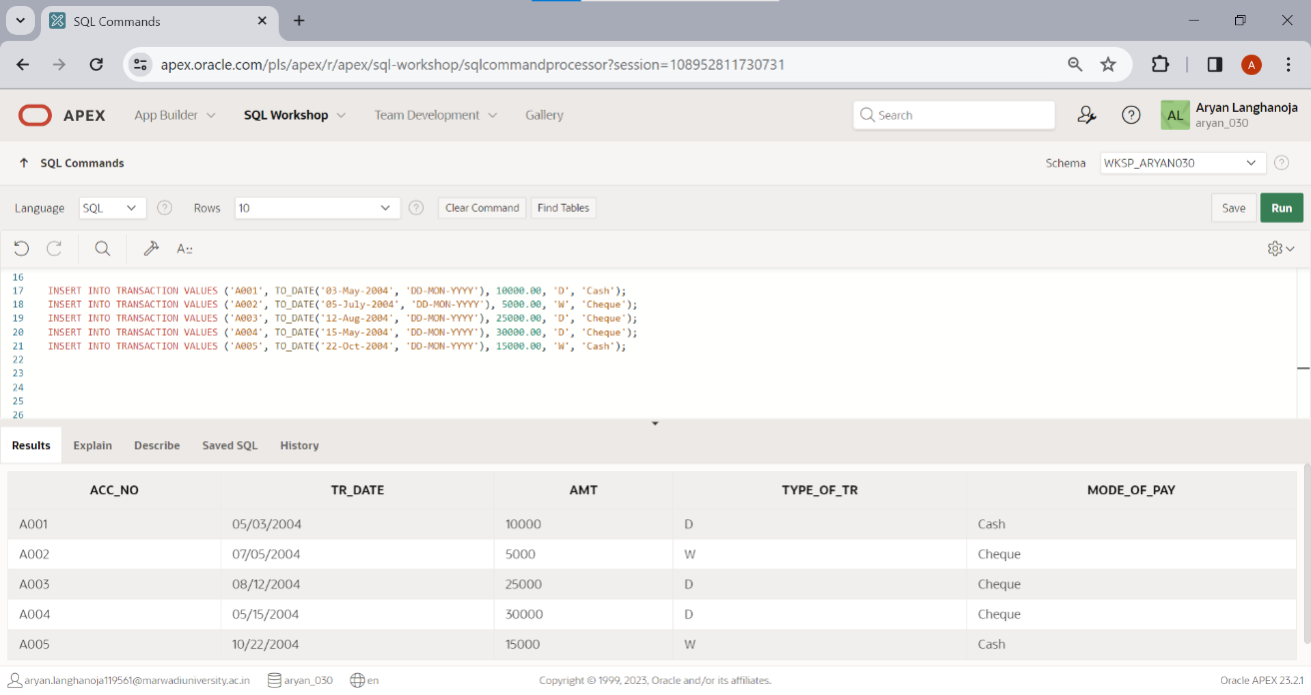

**Table-Account**

**List of queries**

* 1. 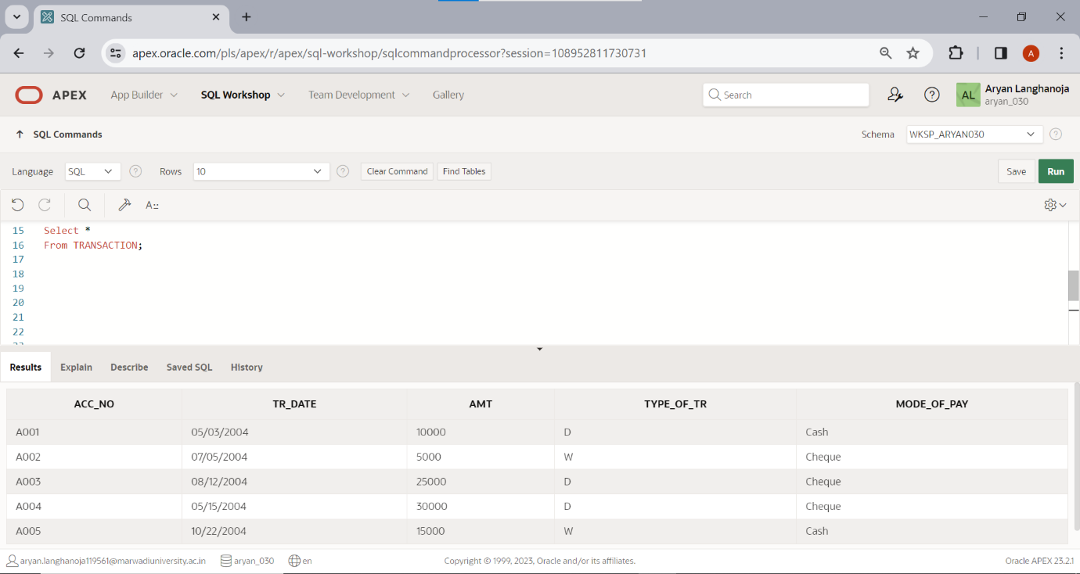Display all rows and all columns of table Transaction.
  2. 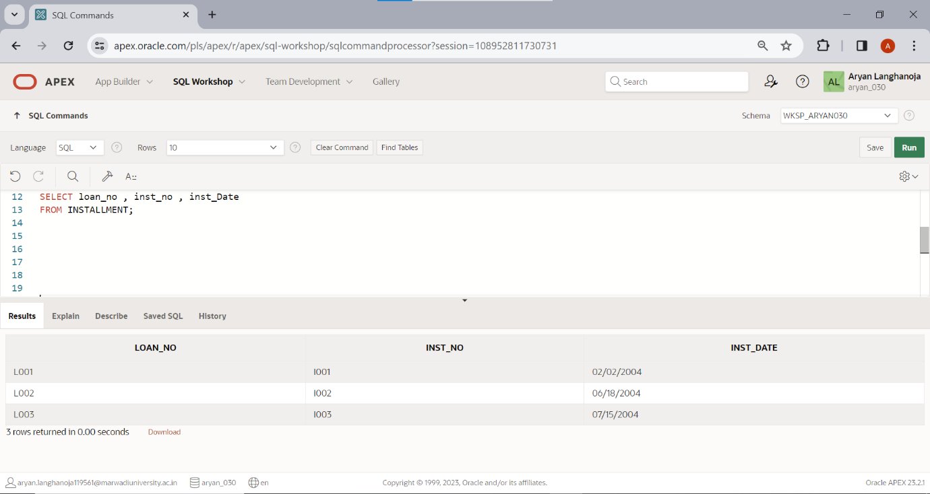Display all rows and selected columns of table Installment.
  3. 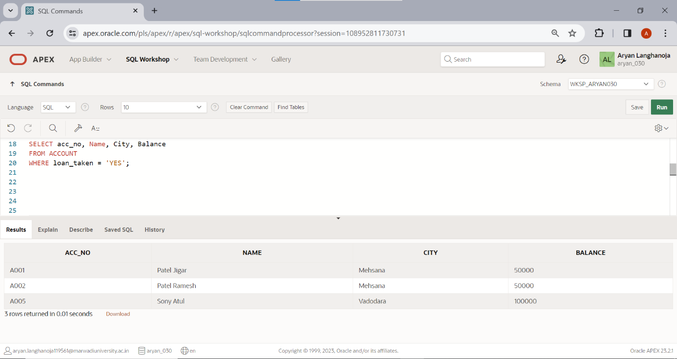Display selected rows and selected columns of table Account.
  4. 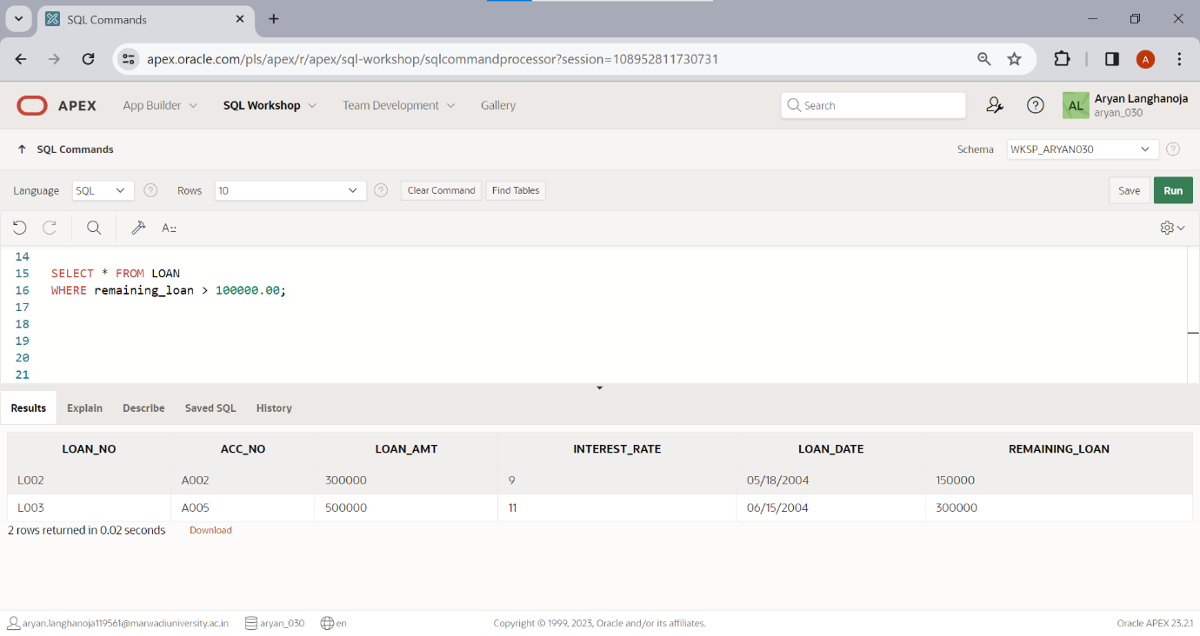Display selected rows and all columns of table loan.
  5. Show the structure of the table loan, account and transaction.

desc loan;

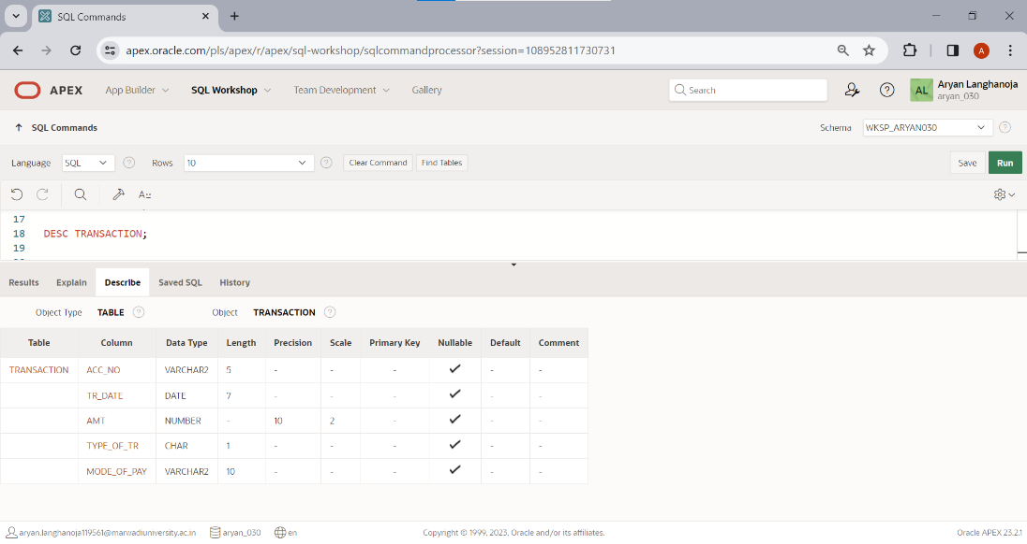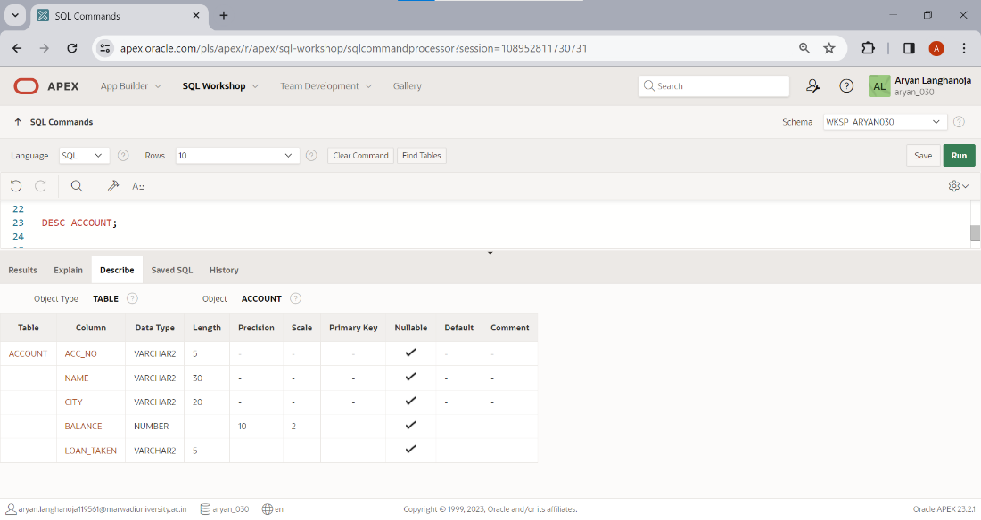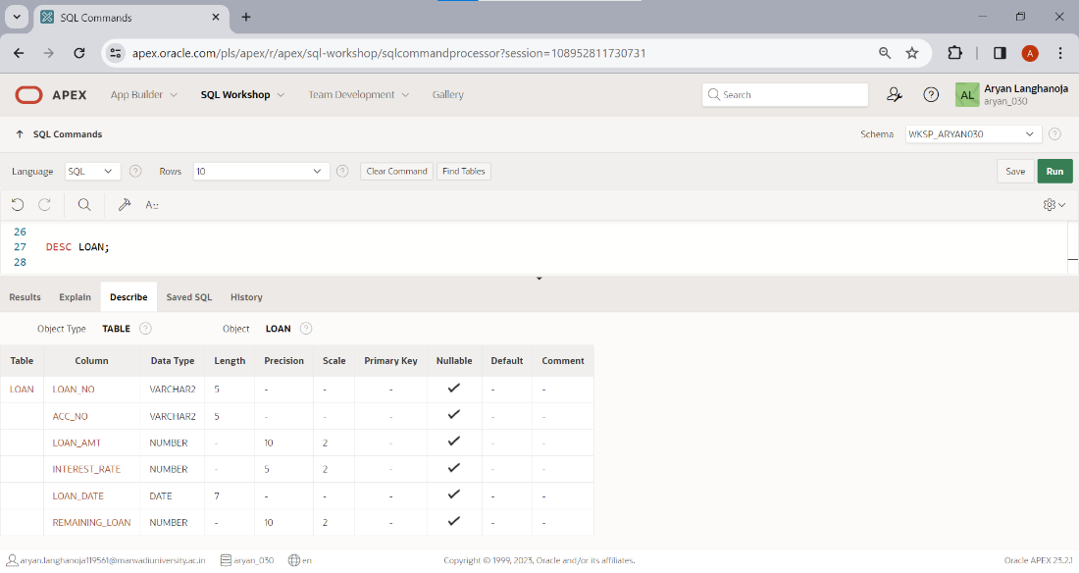

**Practical 3**

**Aim: DML Commands and Queries**

Table: **ACCOUNT**.

Insert the following records if you have not inserted in PRACTICAL - 1

|  |  |  |  |  |
| --- | --- | --- | --- | --- |
| **Acc_no** | **Name** | **City** | **Balance** | **Loan_taken** |
| A001 | Patel Jigar | Mehsana | 50000 | YES |
| A002 | Patel Ramesh | Mehsana | 50000 | Yes |
| A003 | Dave Hardik | Ahmedabad | 75000 | NO |
| A004 | Soni Hetal | Ahmedabad | 100000 | NO |
| A005 | Soni Atul | Vadodara | 100000 | YES |

1. Change the name ‘patel jigar’ to ‘patel hiren’.

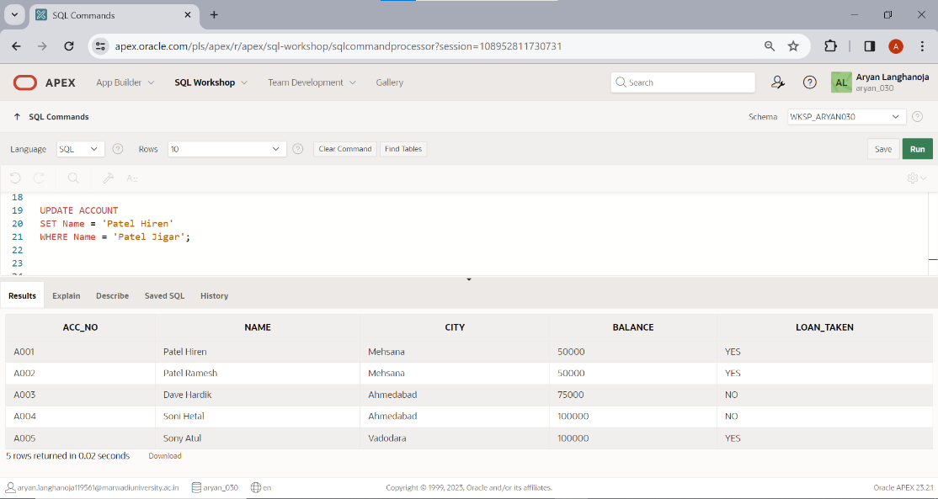

1. Change the name and city where account number is A005. (new name = ‘kothari nehal’ and new city = ‘patan’).

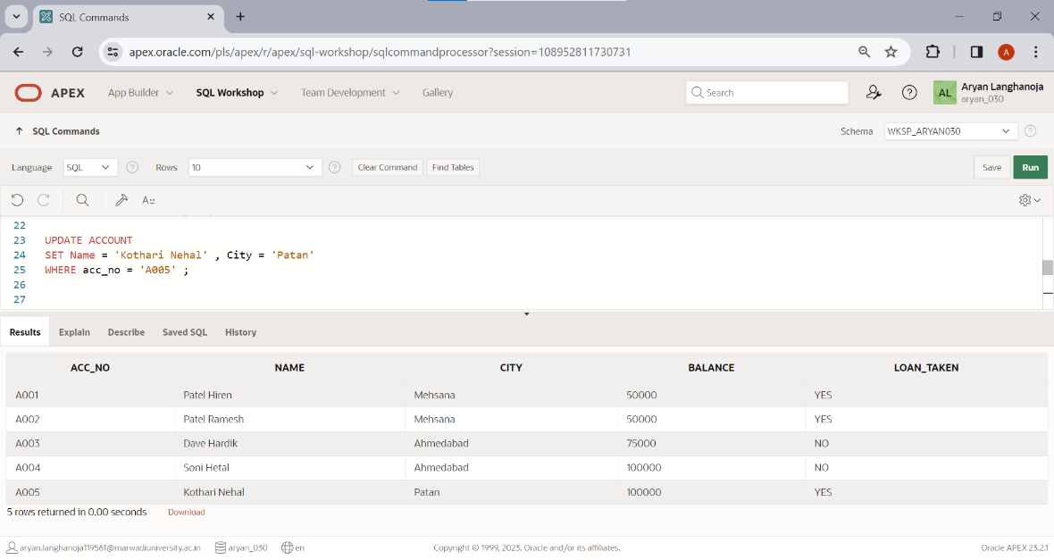

1. 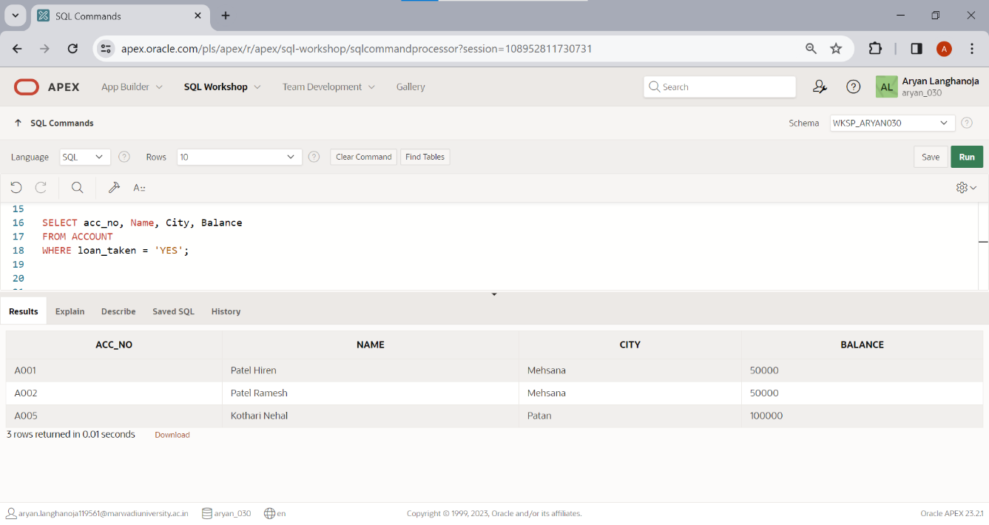Display only those records where loan taken status is ‘YES’.
2. 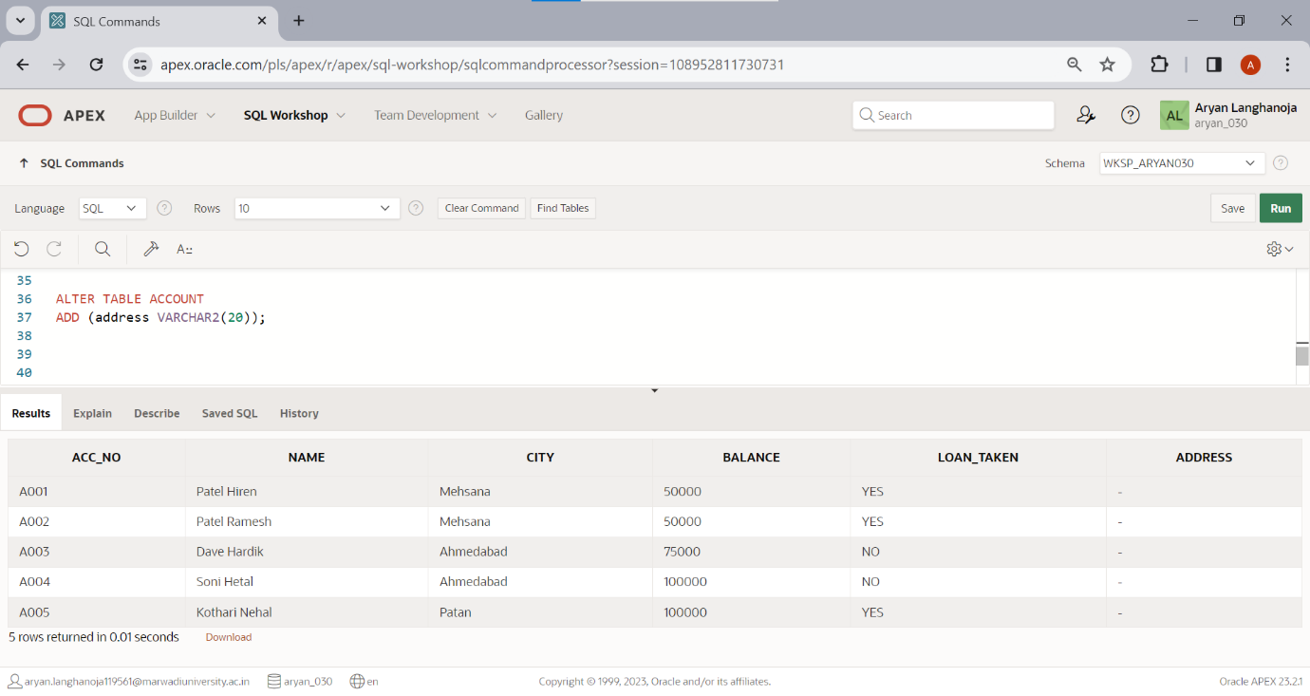Add the new column (address varchar2 (20)) into table ACCOUNT.
3. 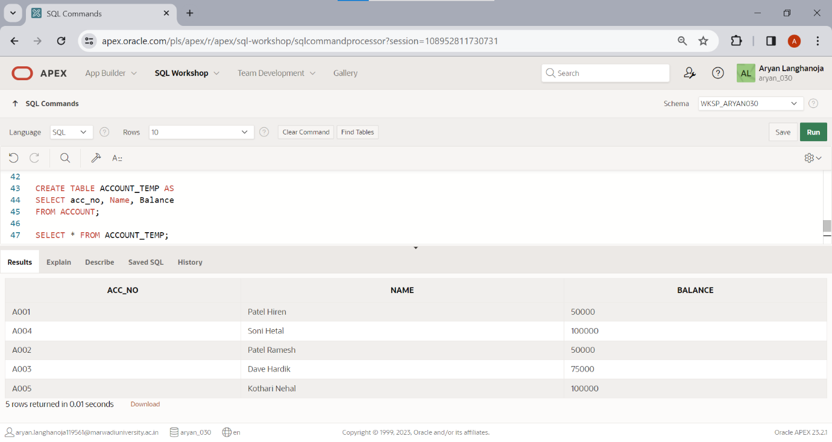Create another table ACCOUNT_TEMP (acc_no, name, balance) from table ACCOUNT.
4. 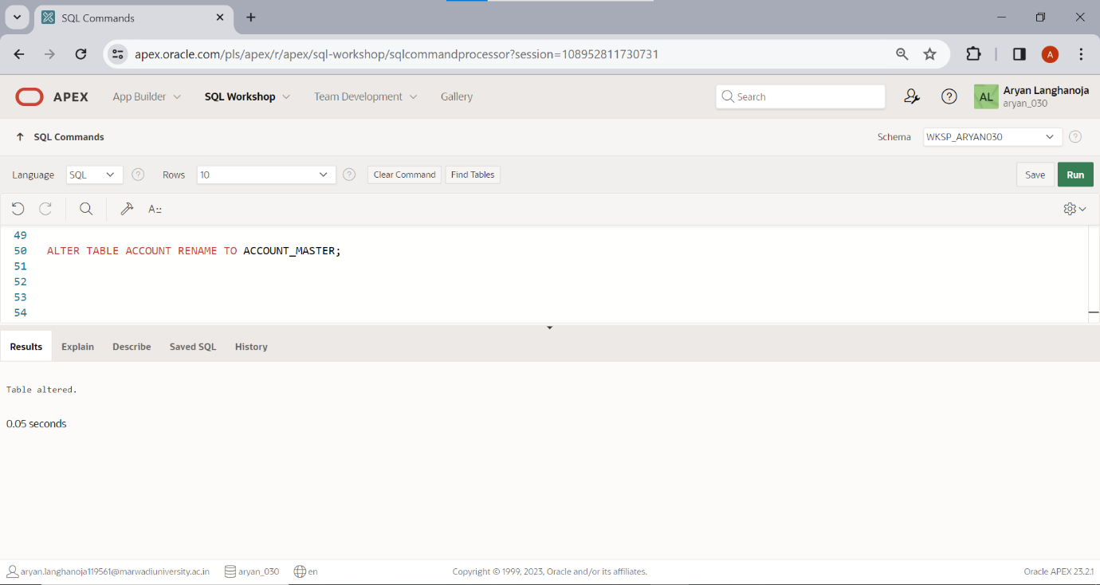Rename the table ACCOUNT to ACCOUNT_MASTER.
5. Update the column balance for all the account holders. (Multiply the balance by 2 for each account holders)

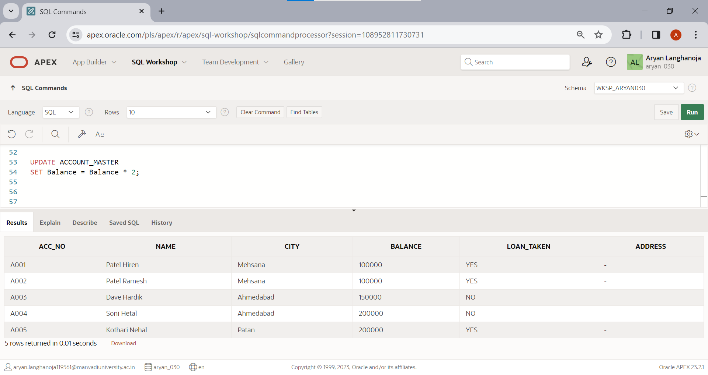

1. 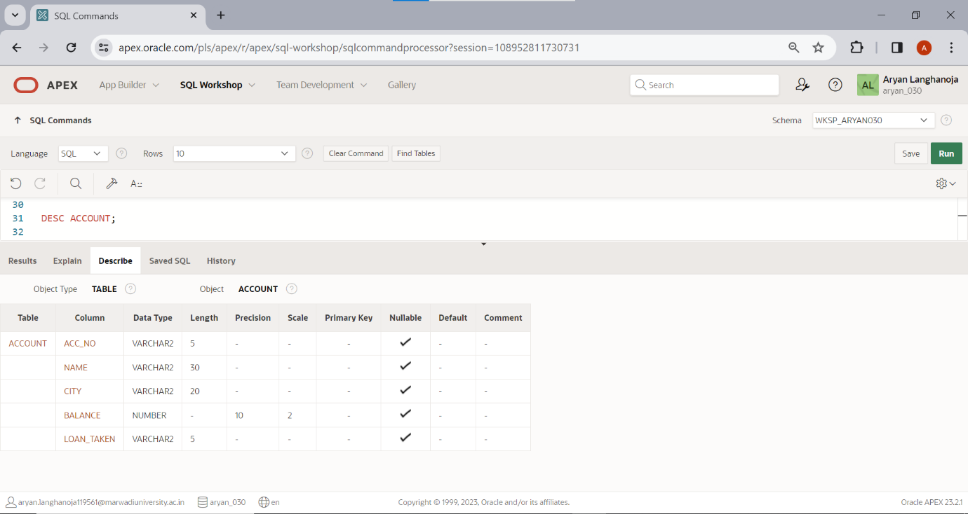Describe the structure of table ACCOUNT.
2. Delete the records whose account no is A004.

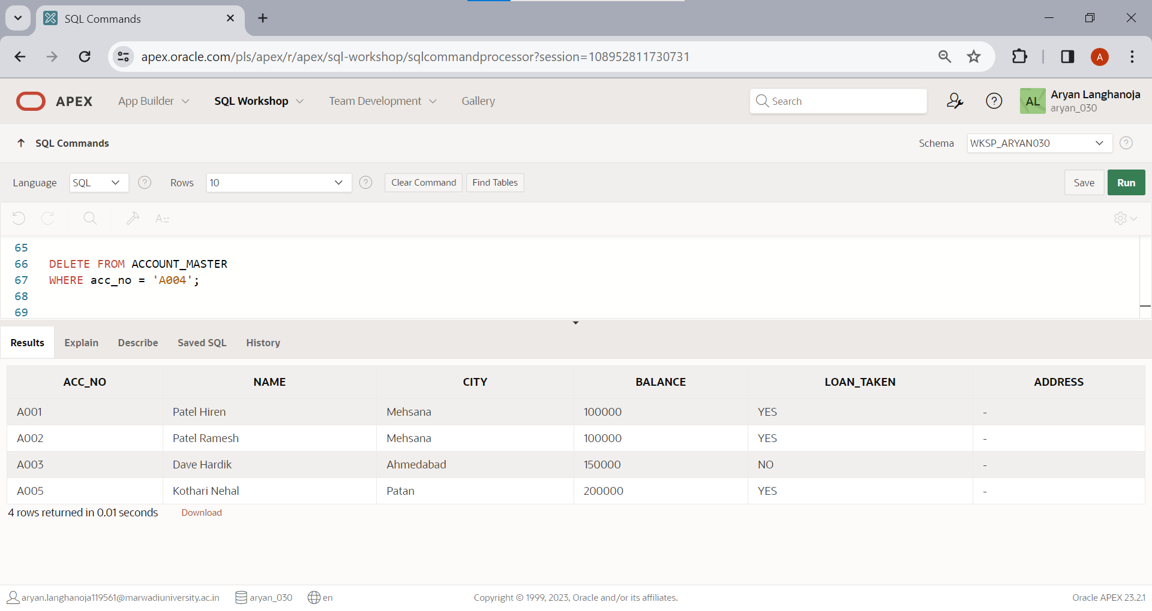

Table: **LOAN**.

Insert the following Records if you have not inserted in PRACTICAL-1

|  |  |  |  |  |  |
| --- | --- | --- | --- | --- | --- |
| **Loan_no** | **Acc_no** | **Loan_amt** | **Interest_rate** | **Loan_date** | **Remaining_loan** |
| L001 | A001 | 100000 | 7 | 1-jan-04 | 75000 |
| L002 | A002 | 300000 | 9 | 18-may-04 | 150000 |
| L003 | A005 | 500000 | 11 | 15-june-04 | 300000 |

1. For each loan holders Add 100000 Rs. Amount into the column loan_amt.

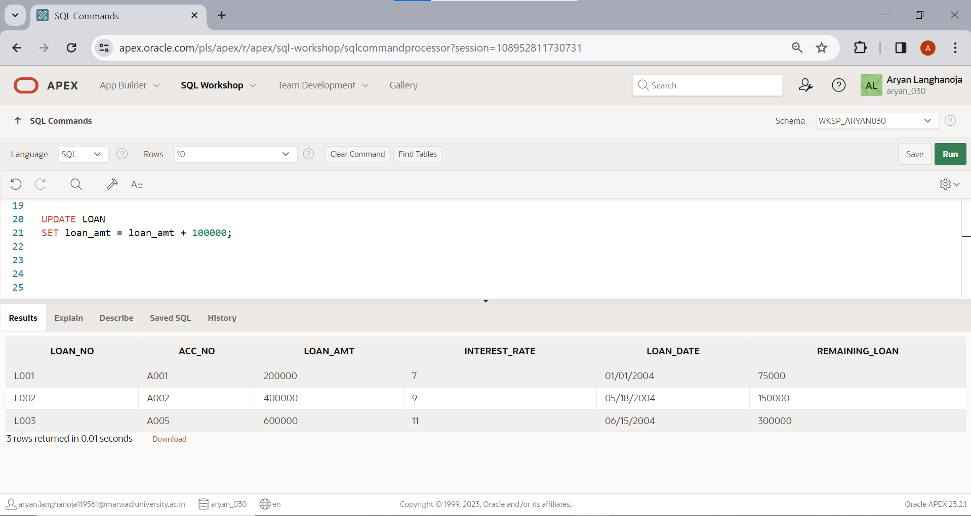

1. 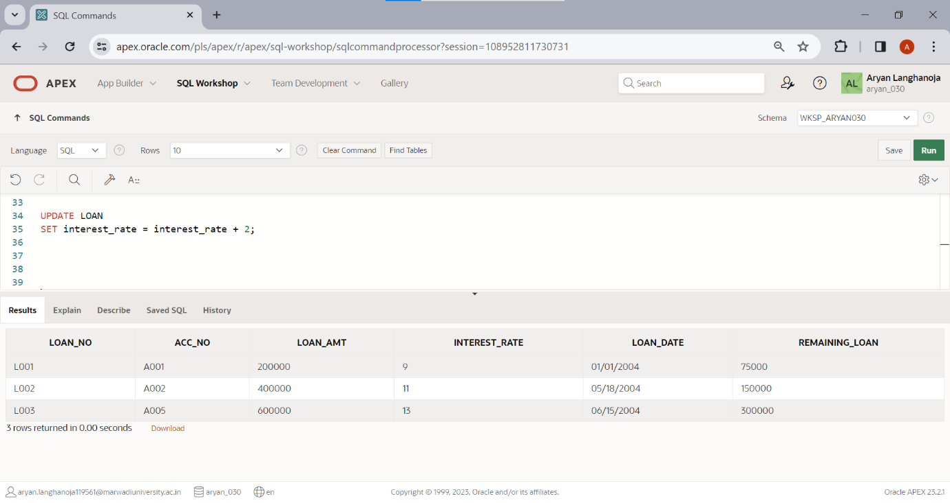for each loan holders Increase the interest rate 2%.
2. Create another table LOAN_TEMP (loan_no, Acc_no, loan_amt, loan_date) from The table LOAN.

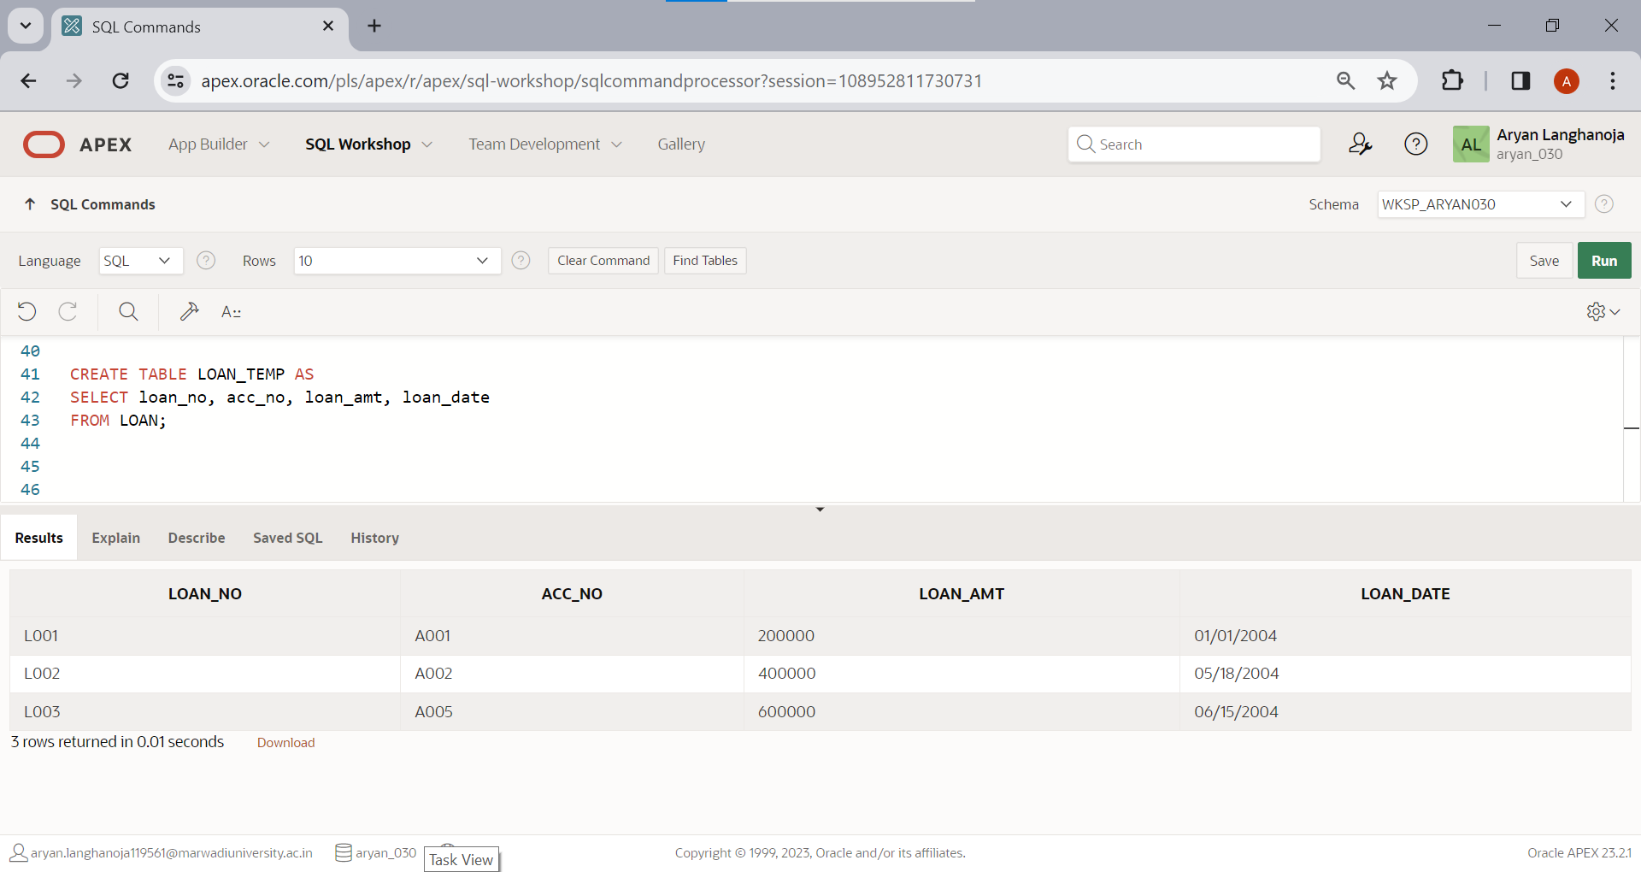

1. Display only those records where loan holder taken a loan in month of January.

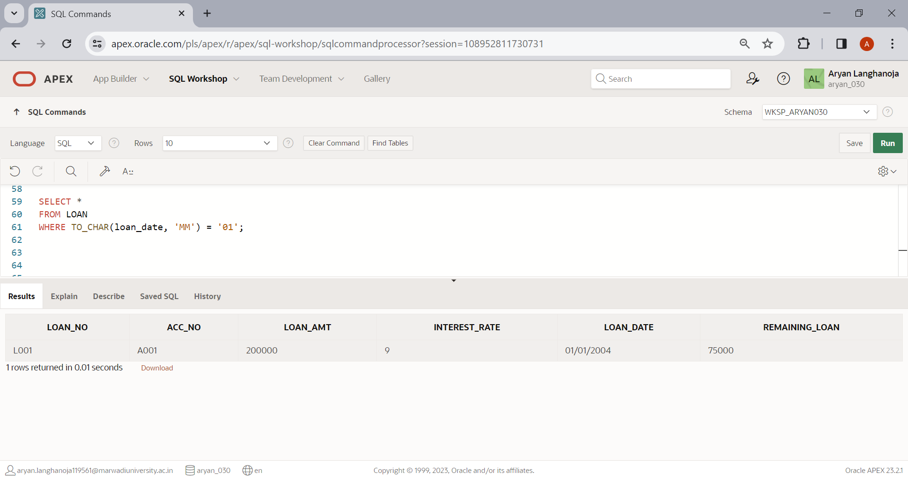

1. Modify the structure of table LOAN by adding one column credit_no varchar2 (4).

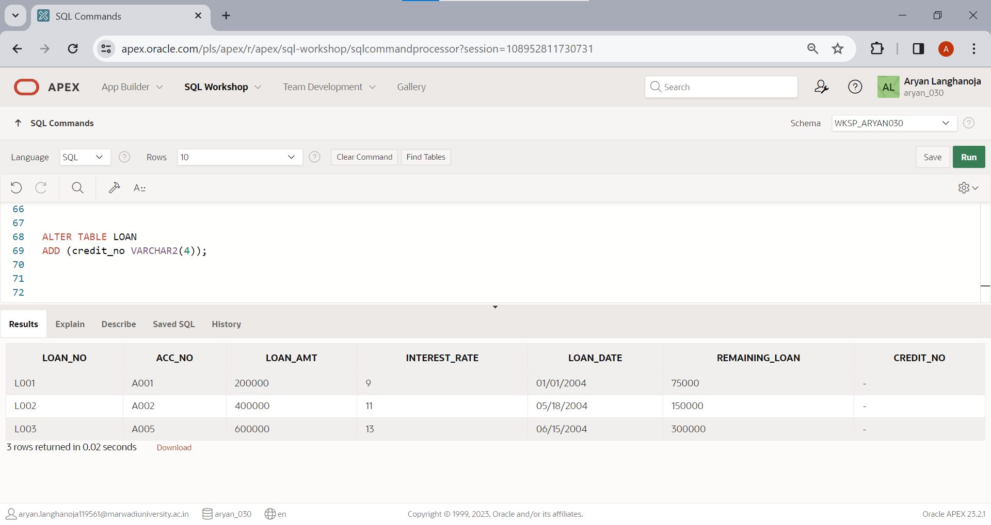

1. Display the Loan amount*2 of table LOAN.

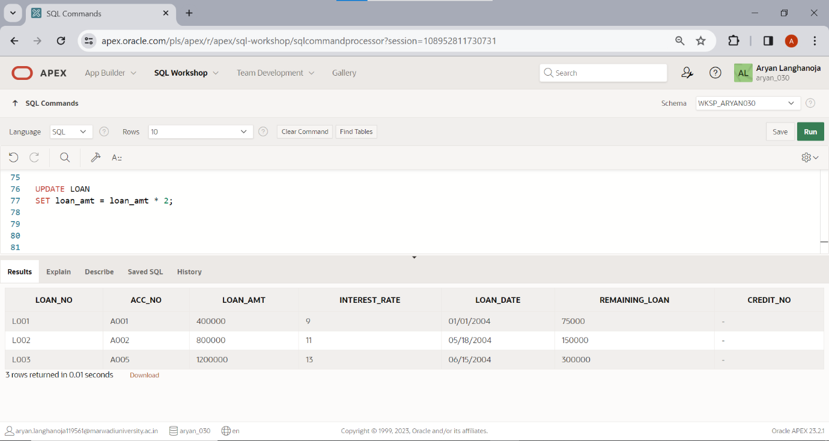

1. 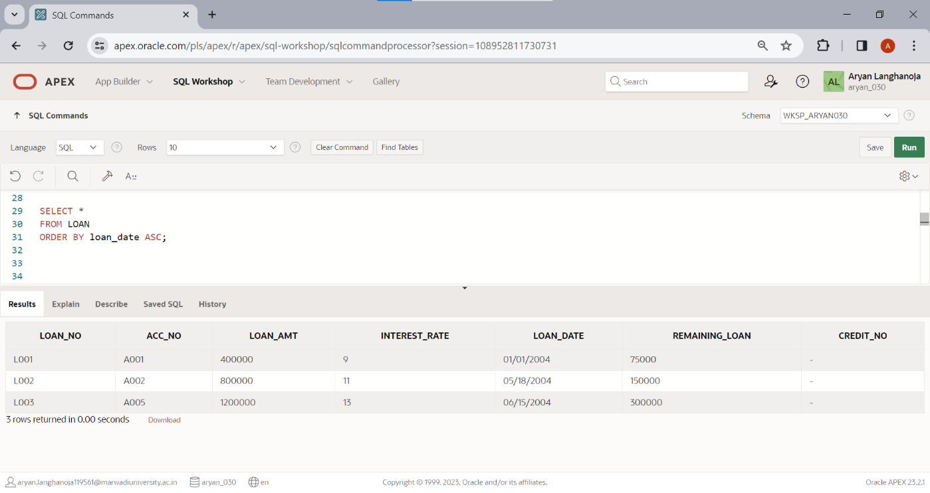Display the records of table LOAN by date wise in ascending order.
2. Display the records of table LOAN by account number wise in descending Order.

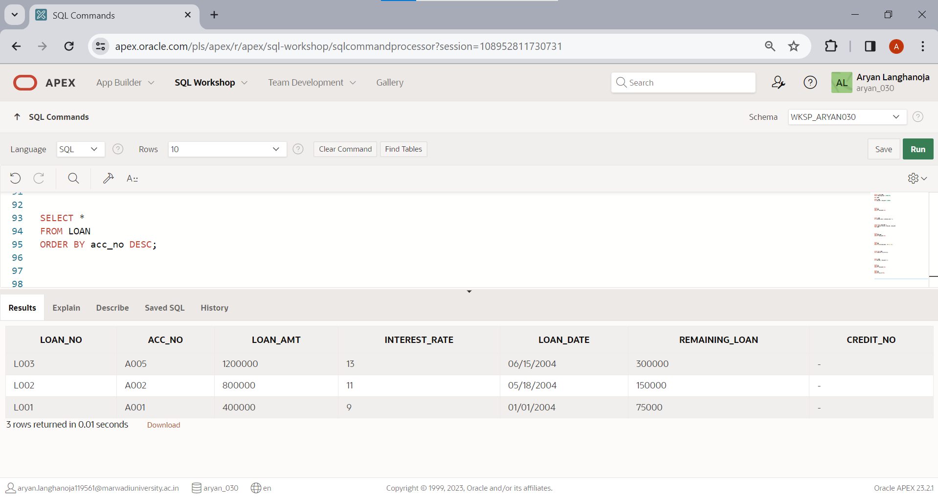

**Practical 4**

**Aim:** **DML Commands and Related Queries**

Table: **INSTALLMENT**.

* 1. Insert following Records if you have not inserted in PRACTICAL-1.

|  |  |  |  |
| --- | --- | --- | --- |
| **Loan_no** | **Inst_no** | **Inst_Date** | **Amount** |
| L001 | I001 | 2-Feb-04 | 15000 |
| L002 | I002 | 18-June-04 | 20000 |
| L003 | I003 | 15-July-04 | 20000 |

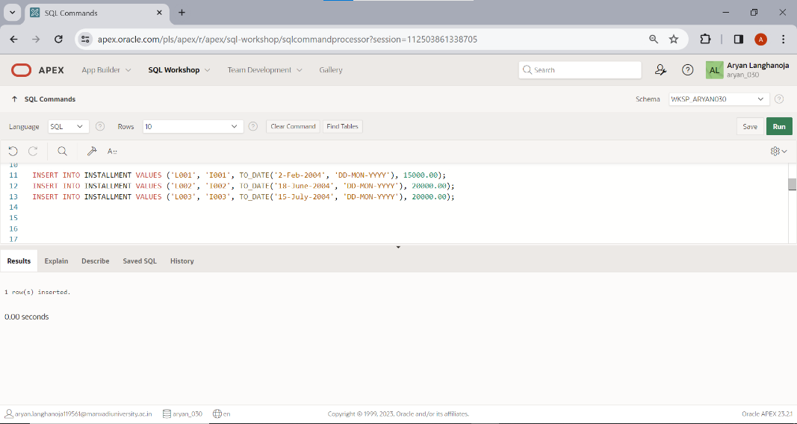

1. Change the Inst_Date ‘2-Feb-04’ to ’3-Mar-04’.

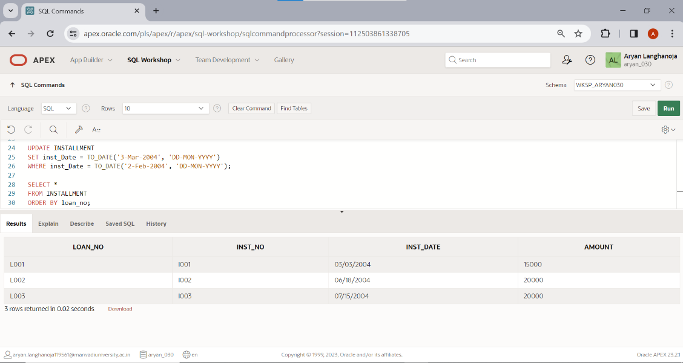

1. Reduce 5000 amount from all Installment holders.

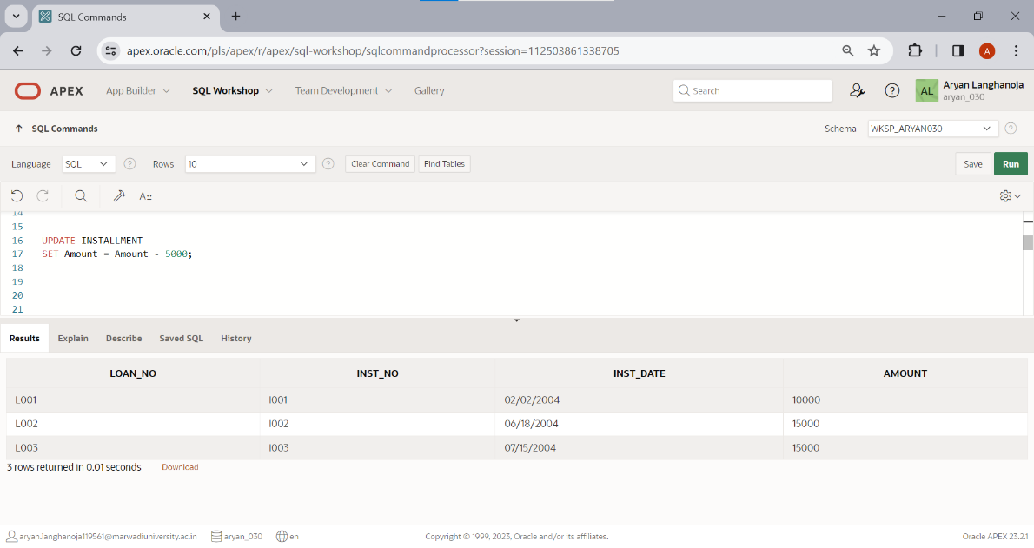

1. Add the amount 5000 where loan no is ‘L003’ and ‘L002’.

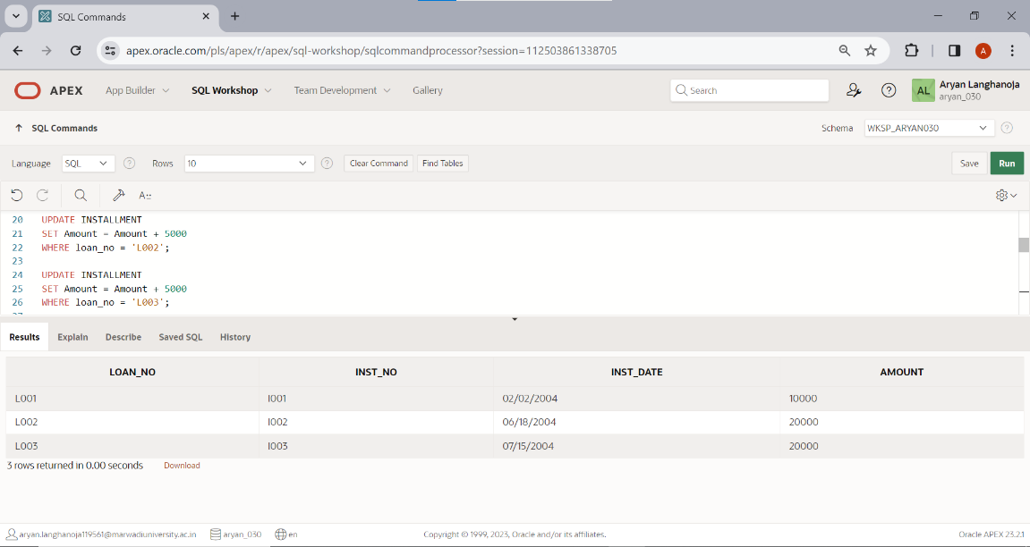

1. Change the column size of 5 to 7 where column name is Loan_no.

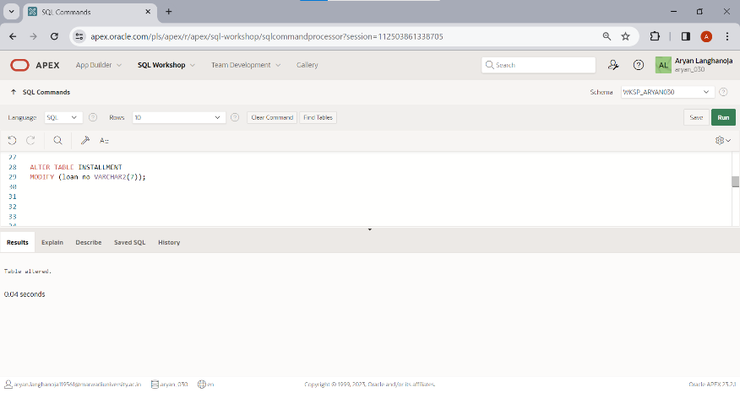

1. Decrease the column size 5 to 4 where column name Inst_no.

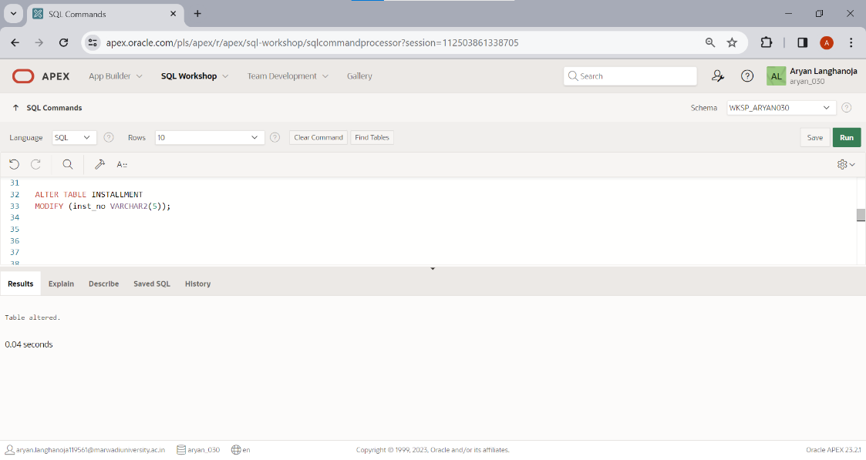

1. Show the structure of the Table.

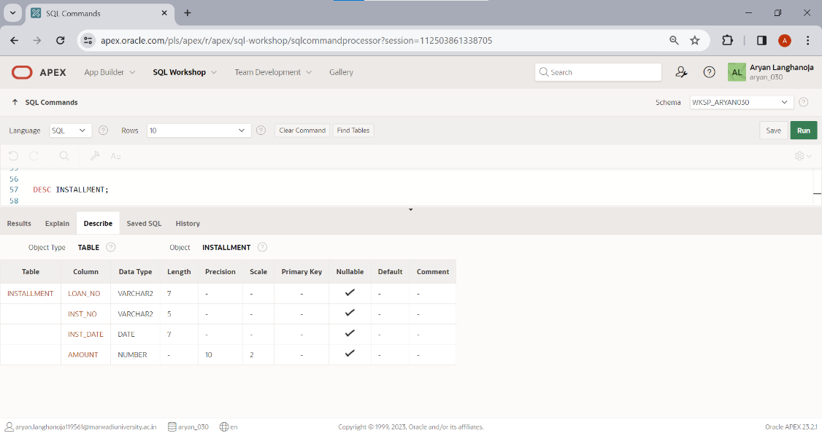

1. Change the amount 15000 to 5000 where loan number is L001

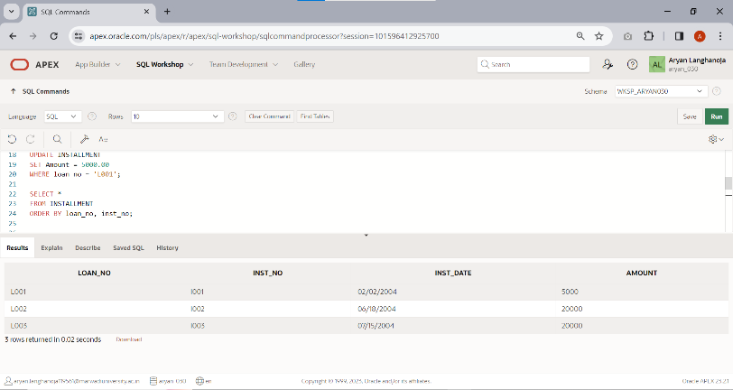

1. 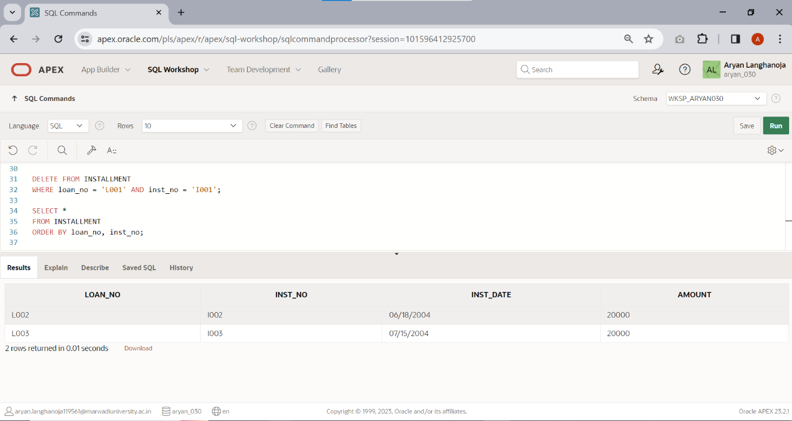Perform delete operation. (Delete only particular one record)
2. 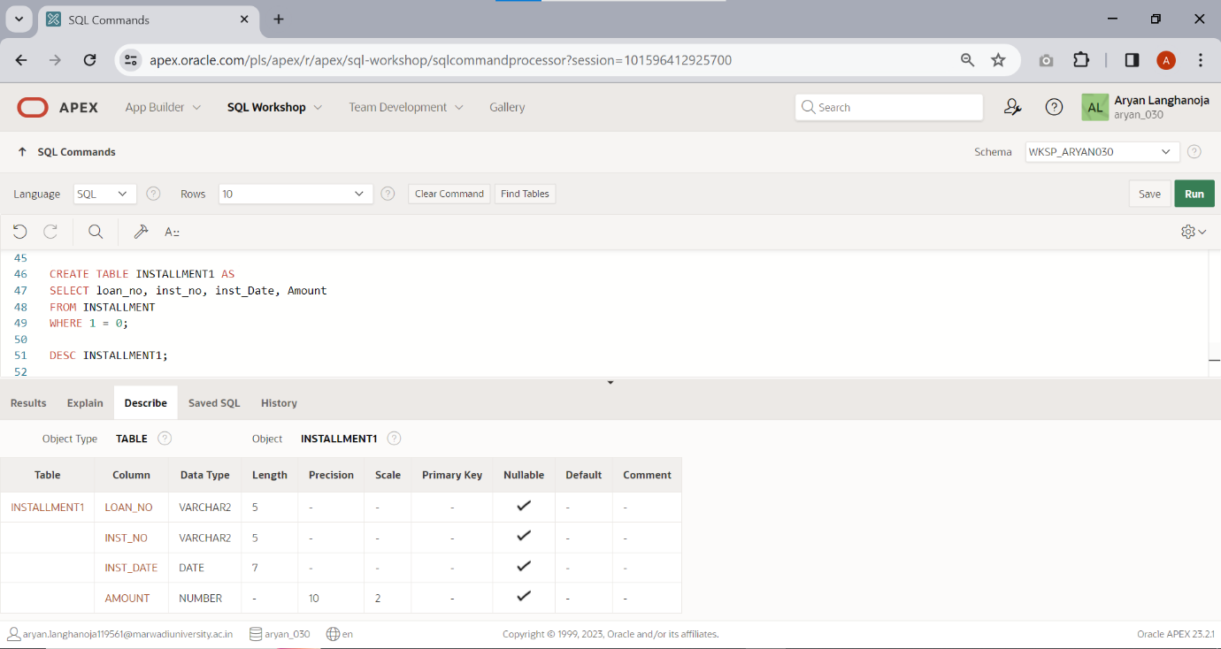Only create a structure of table installment1 from table installment.

Table: **TRANSACTION**.

* + 1. 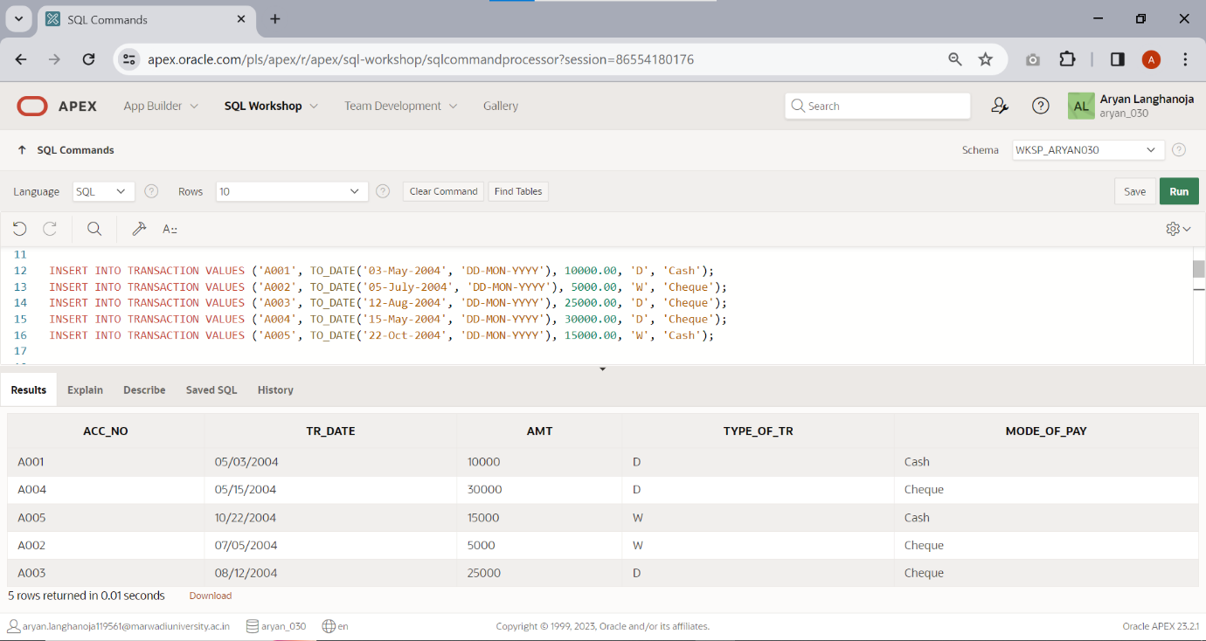Insert a Following Records if you have not inserted in PRACTICAL-1.

|  |  |  |  |  |
| --- | --- | --- | --- | --- |
| **Acc_no** | **Trans_Date** | **Amt** | **Type_of_tr** | **Mode_of_pay** |
| A001 | 3-may-04 | 10000 | D | Cash |
| A002 | 5-july-04 | 5000 | W | Check |
| A003 | 12-Aug-04 | 25000 | D | Check |
| A004 | 15-may-04 | 30000 | D | Check |
| A005 | 22-oct-04 | 15000 | W | Cash |

* + 1. 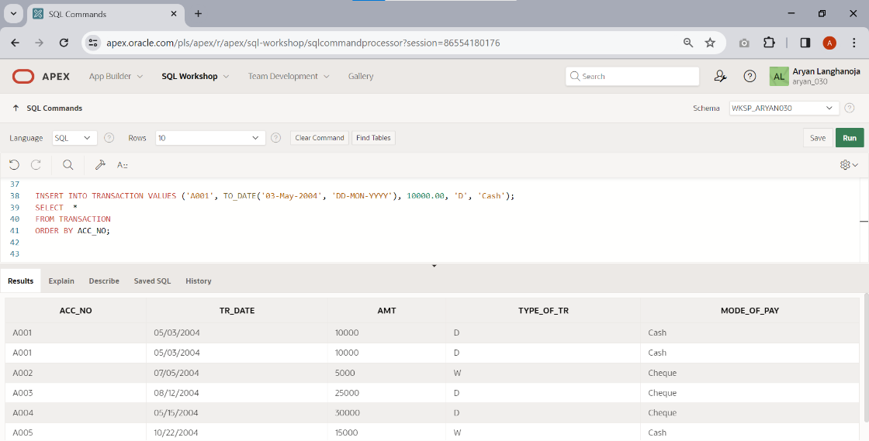Insert any duplicate value and display all the records without any duplicate rows.
    2. 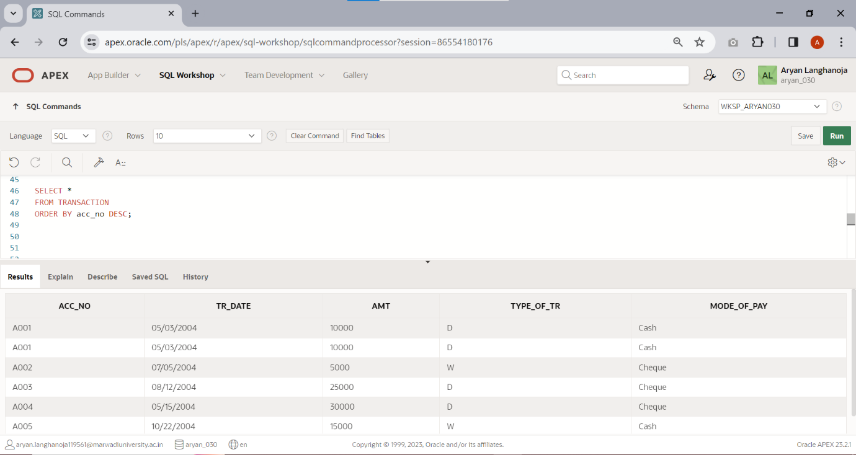Select all the records in descending order(account number wise).
    3. 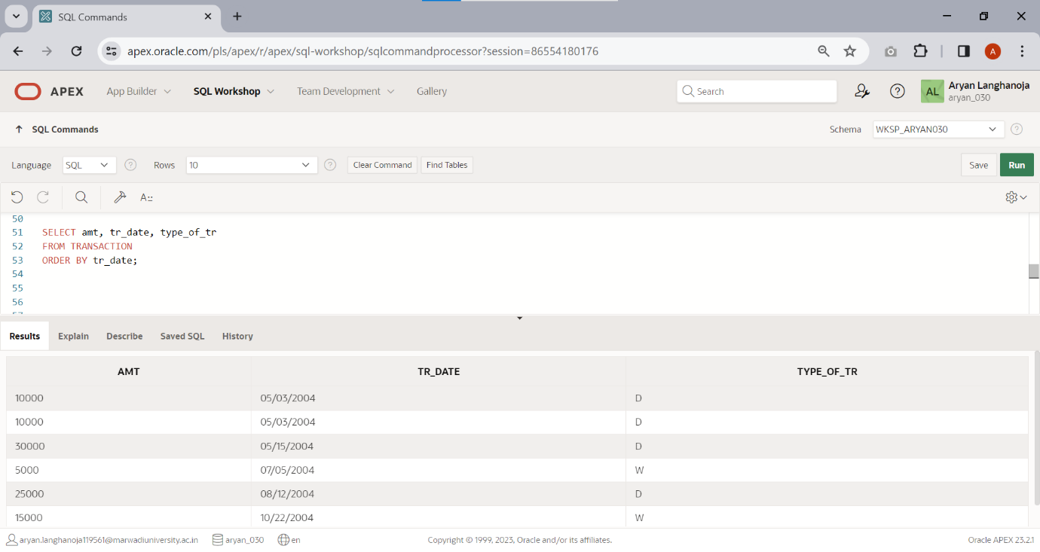Display amt, date, and type of transaction by date wise.
    4. 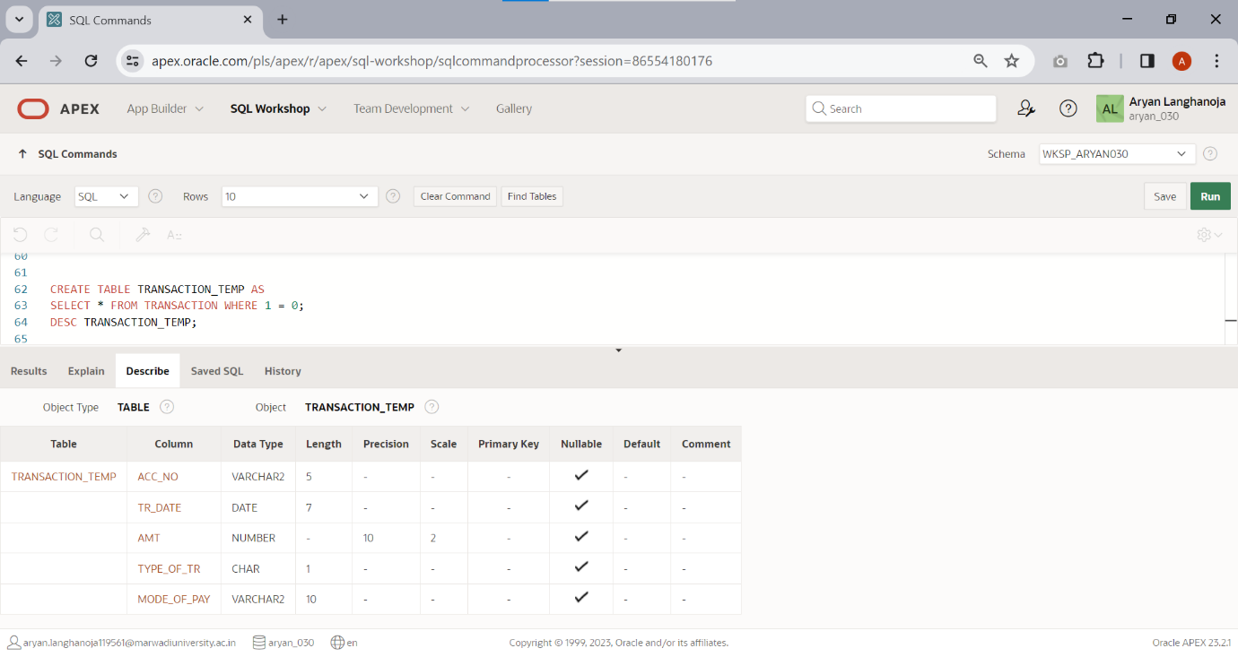Create another table TRANSACTION_TEMP from this table.
    5. 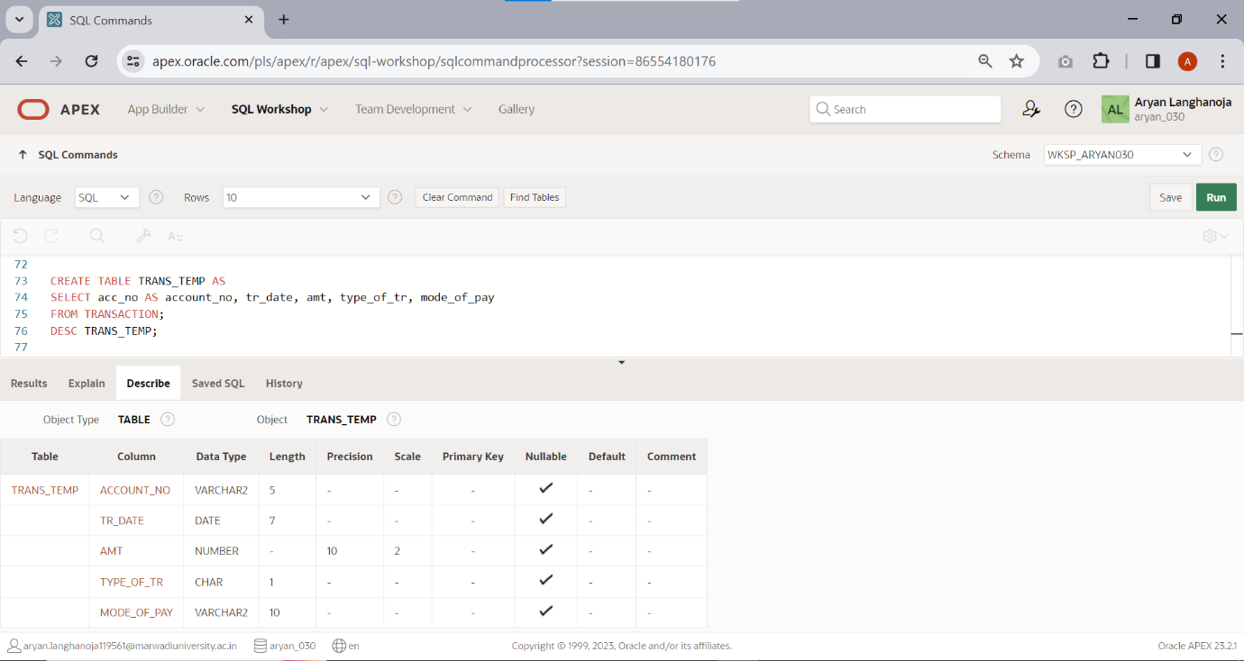Create a another table TRANS_TEMP by change the column name acc_no to account_no.
    6. 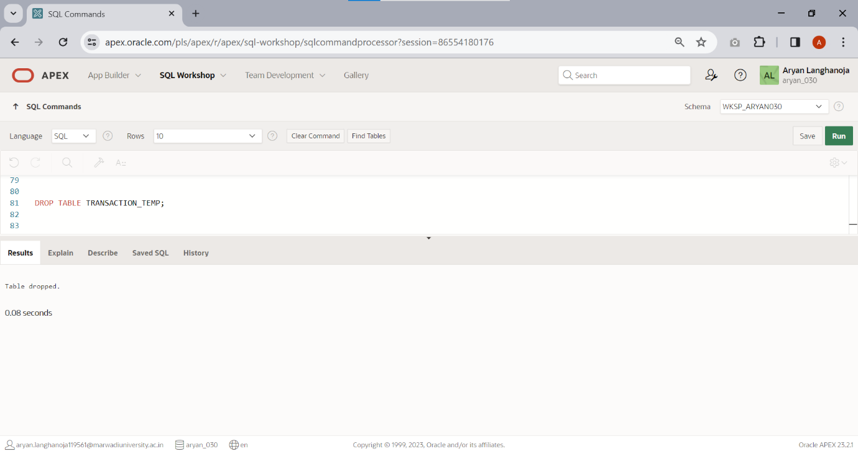Delete a table TRANSACTION_TEMP.
    7. 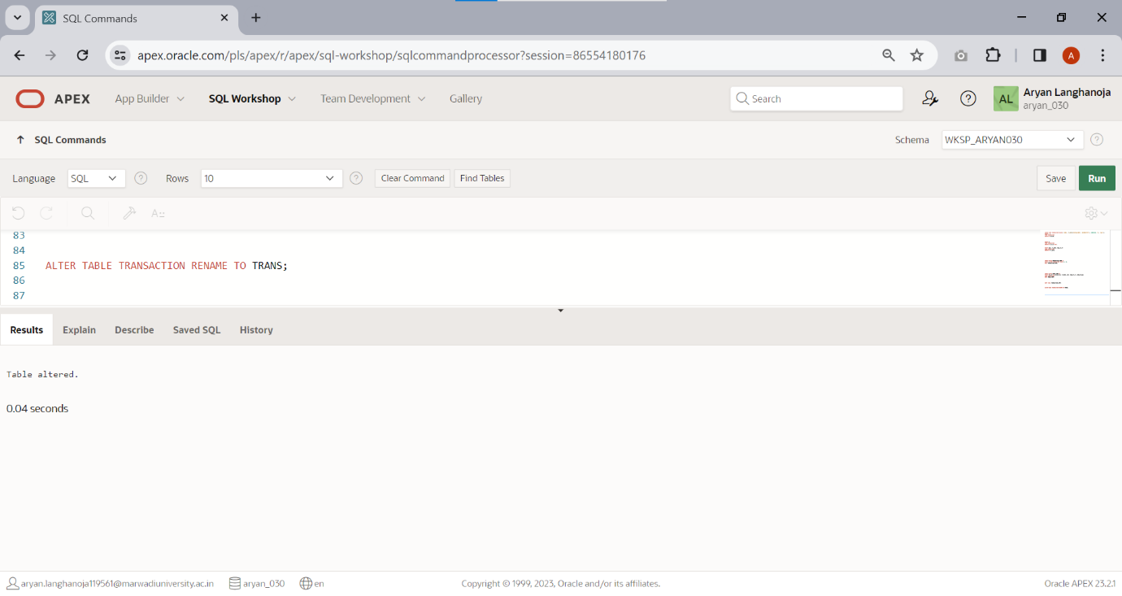Rename the table TRANSACTION to TRANS.
    8. 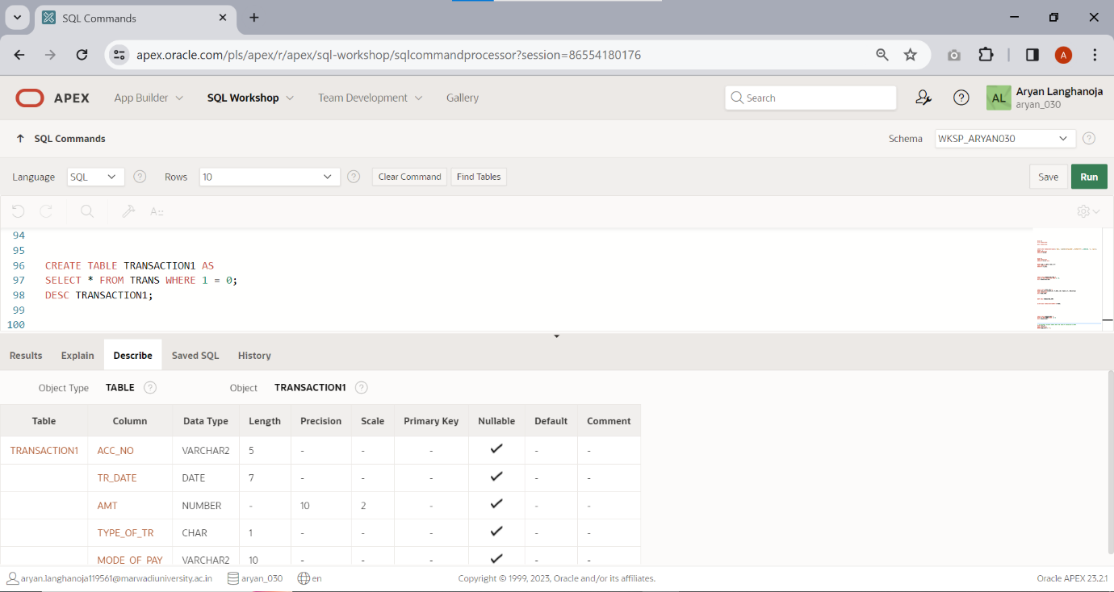 Only create a structure of table transaction1 from table transaction.
    9. Display account number where type of transaction is ‘D’.

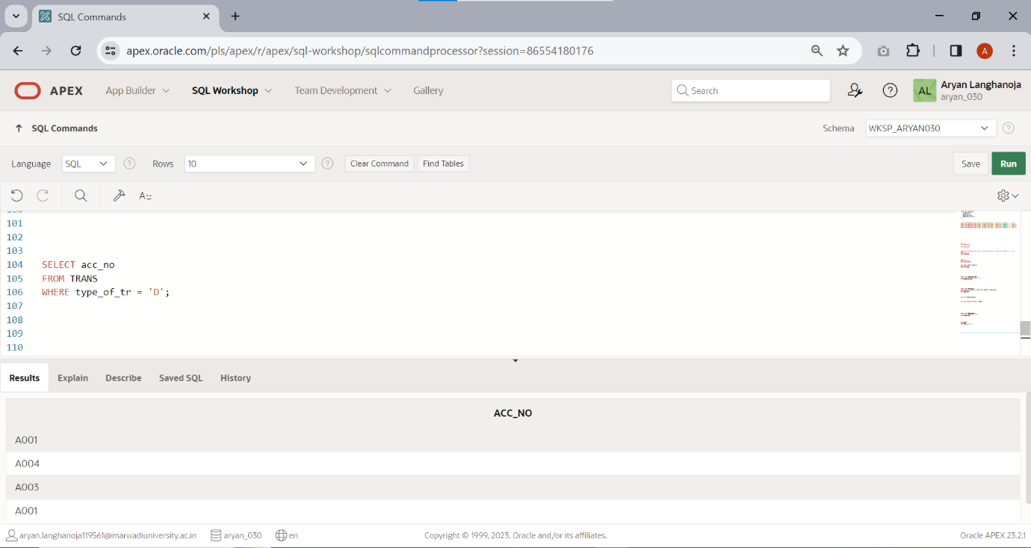

**Practical 5**

**Aim: Constraint Based DML Commands**

**Note: Bold and Underline column name indicates a primary key**

Create a table **ACCOUNT**.

|  |  |  |  |
| --- | --- | --- | --- |
| **Column name** | **Data Type** | **Size** | **Attributes** |
| **Acc_no** | Varchar2 | 5 | Primary key/first letter must start with ‘A’ |
| Name | Varchar2 | 30 | NOT NULL |
| City | Varchar2 | 20 | NOT NULL |
| Balance | Number | 10,2 | Balance >=500 |
| Loan_taken | Varchar2 | 3 | Values(‘NO’,’YES’) |

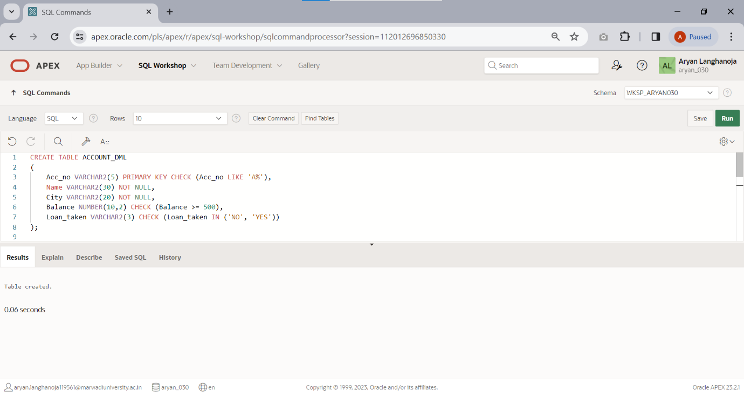

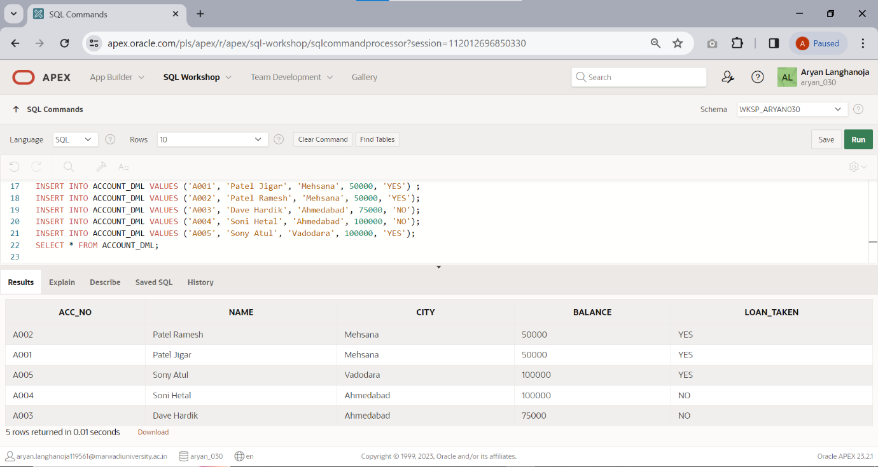1. Insert the records using Practical list 1.

Create a Table **LOAN**.

|  |  |  |  |
| --- | --- | --- | --- |
| **Column Name** | **Data**  **Type** | **Size** | **Attributes** |
| **Loan_no** | Varchar2 | 5 | Primary Key / first letter must start with ‘L’ |
| Acc_no | Varchar2 | 5 | Foreign key References Acc_no of account  table |
| Loan_amt | Number | 10,2 | NOT NULL |
| Interest_rate | Number | 5,2 | NOT NULL |
| Loan_date | Date |  |  |
| Remaining_loan | Number | 10,2 | Remaining loan<loan amount |

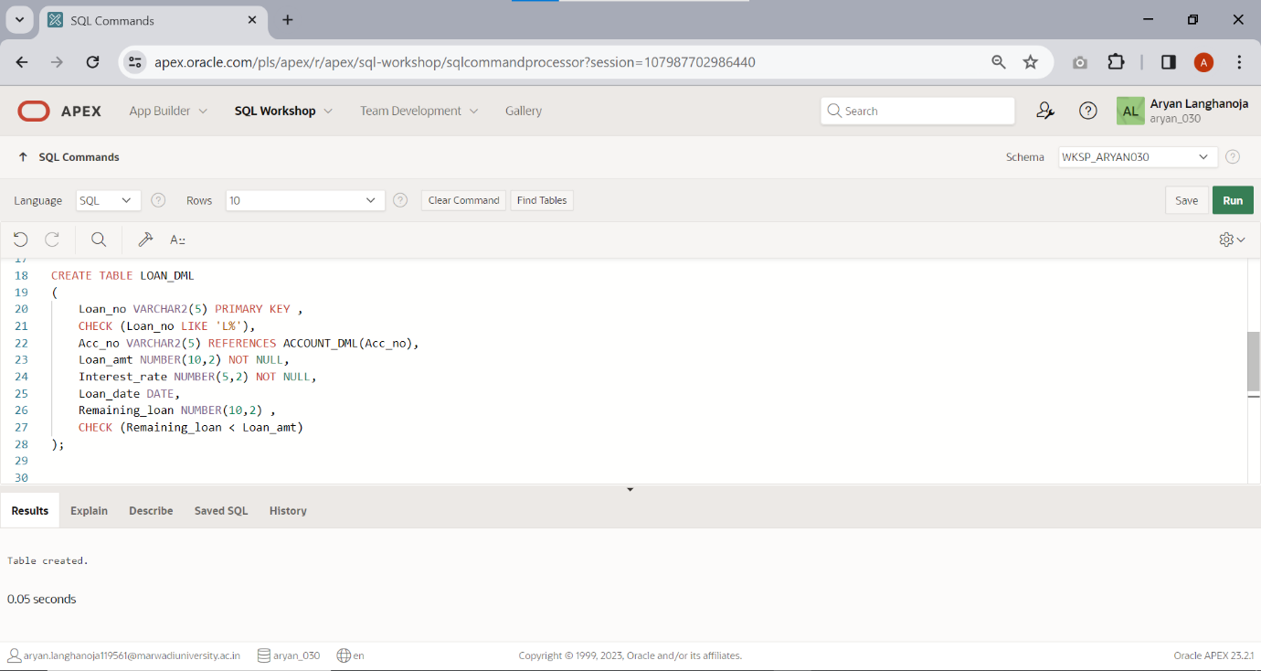

1. 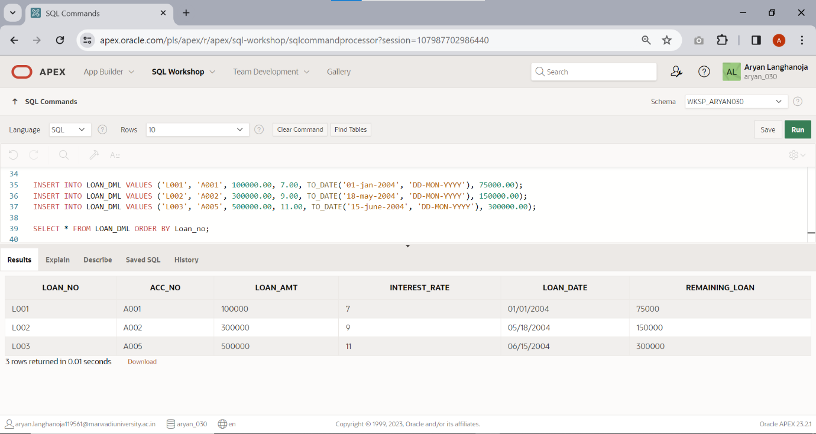Insert the records using practical list-1.

Create a table **INSTALLMENT**.

|  |  |  |  |
| --- | --- | --- | --- |
| **Column Name** | **Data Type** | **Size** | **Attributes** |
| **Loan_no** | Varchar2 | 5 | Foreign key References Loan_no of Loan table |
| Inst_no | Varchar2 | 5 | first letter must start with ‘I’ |
| IDate | Date |  | NOT NULL |
| Amount | Number | 10,2 | NOT NULL |

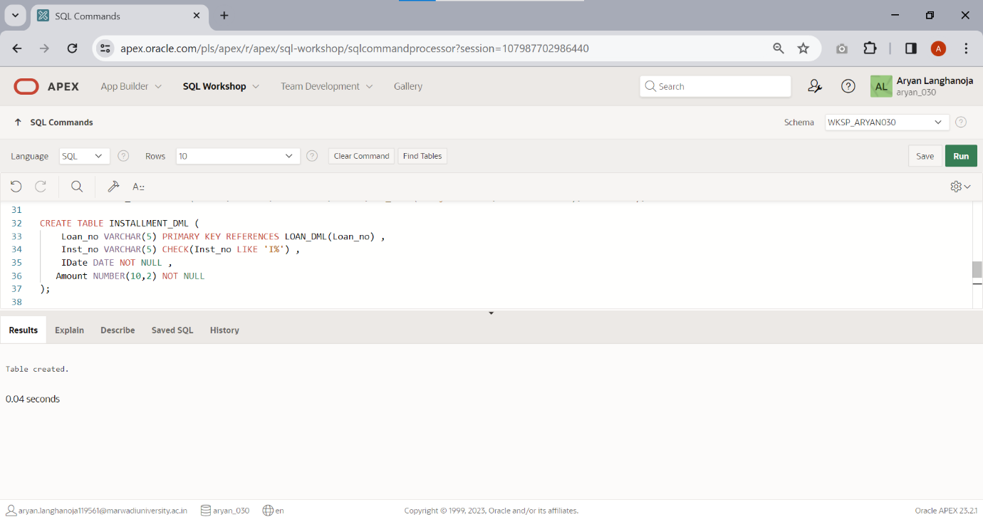

1. Insert the records using Practical list-1

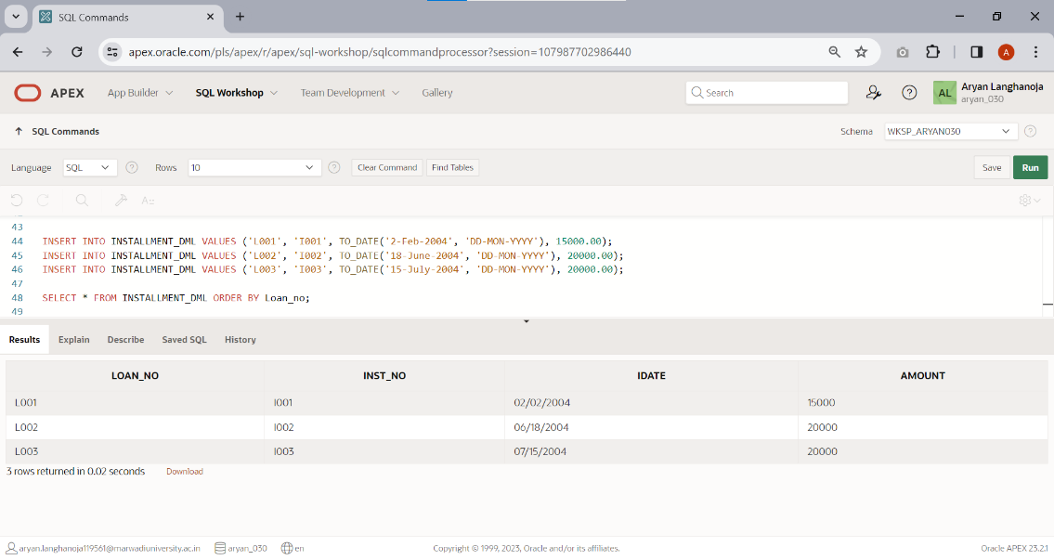

Create a Table **X** .

|  |  |  |  |
| --- | --- | --- | --- |
| **Column Name** | **Data Type** | **Size** | **Attributes** |
| **Acc_no** | Varchar2 | 5 | Foreign key References Acc_no of account table |
| Trans_Date | Date |  | NOT NULL |
| Amt | Number | 10,2 | NOT NULL |
| Type_of_tr | Char | 1 | Values in (‘D’,’W’) |
| Mode_of_pay | Varchar2 | 10 | Values in (‘cash’,’check’) |

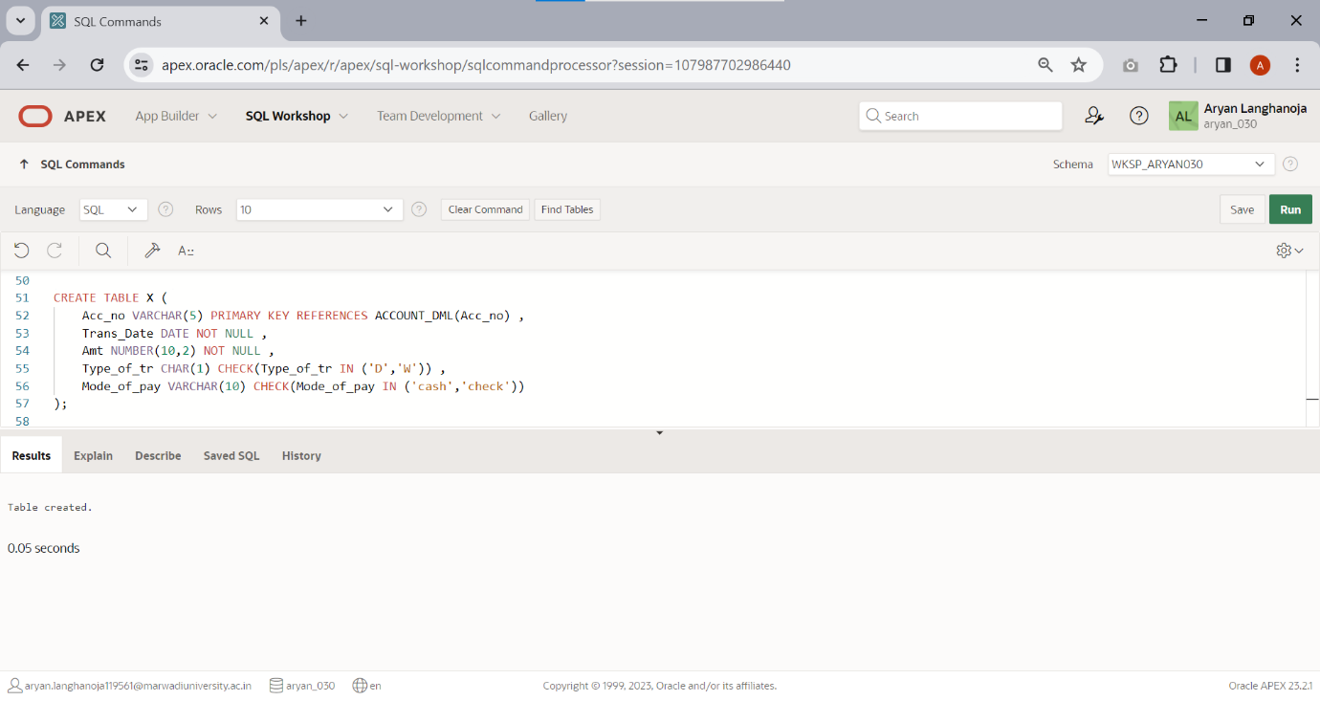

1. Insert the records using Practical list-1.

